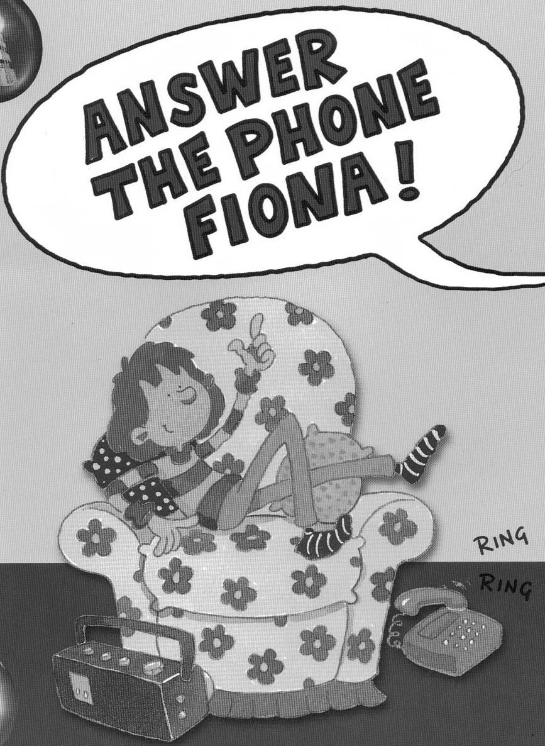
by John Priest

Name_____________________

(Blue Band)

Underline the correct word to complete each sentence.

1. It was a sunny Sunday
afternoon

morning

evening

2. Mum and dad were
at the shops

in the garden

upstairs

sing

dance

shout
3. Fiona started to

door

radio

phone
4. Dad shouted answer the

Draw a line to join the beginning and end of each sentence.

1. Fiona was rang.

2. The phone started to cross.

3. Get the phone downstairs.

4. The phone still Fiona!

5. Then the phone ring.

6. Dad and mum looked stopped.

Decide whether each sentence is TRUE, FALSE or if you CAN’T TELL from the story. Tick ONE box beside each sentence.

 |  | TRUE | FALSE | CAN’T  TELL
1. | Fiona did not like singing.
2. | Mum and dad enjoyed doing the wallpapering.
3. | Dad wished Fiona would stop singing.
4. | Aunt Alice was on the phone.
5. | The wallpaper dad and mum were putting up was blue and green.
6. | Fiona had a pet dog.

Here are some sentences about the passage. Fill in the gaps using one word or two words in each space. You can use your own words or words from the passage.

It was a sunny ___________________________. Fiona was downstairs. Mum and dad were __________________. The phone started ________________________. Fiona started ______________________. Mum and dad shouted ___________________________ Fiona. Fiona kept on singing. The phone kept ________________________. Then the phone stopped ringing and Fiona stopped singing. Mum and dad were_______________________.

