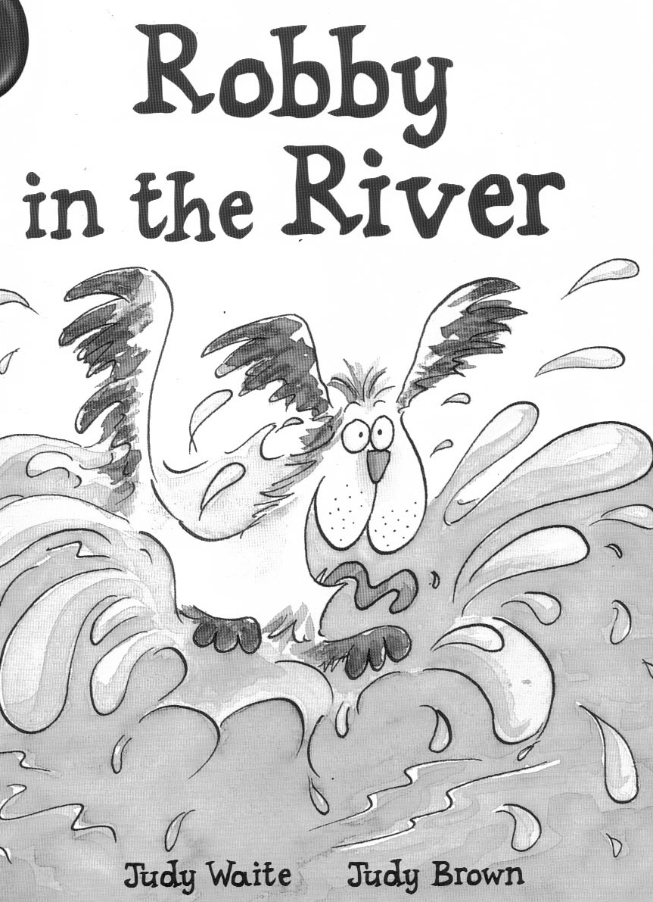

Name________________________________
Date_________________________________

(green band)

Put the story in order.

A: Lucy and dad took Robby for a walk by the river.

B: Lucy got a branch and dad put it in the river.

C: Dad tried to get the branch. He almost slipped into the river.

D: Robby liked fetching the stick.

E: Robby shook himself.

Match the correct beginning and end of each sentence.

1. Lucy and Robby ran down the river.

2. Robby liked fetching the teeth.

3. Robby was swimming round and Lucy.

4. Lucy got the branch and dad put it in the stick.

5. He picked up the branch in his round.

6. Robby shook water all over path.

Underline the correct answer.

1. Lucy and dad took Robby for a walk beside the
river

shops

cars

leaves

track

path
2. Lucy slipped on the muddy

up

out

down
3. Robby could not get

4. Lucy was very
happy

scared

sad

Choose a word from the box to finish each sentence. Use each word once.

things out river

down called stick

1. Robby liked to fetch__________________________.

2. Lucy fell down and the stick went into the ____________.

3. Robby ran after the _________________.

4. Lucy and dad looked_____________________.

5. “Fetch the branch, Robby,” Lucy________________.

6. Dad pulled Robby ______________ of the river.

