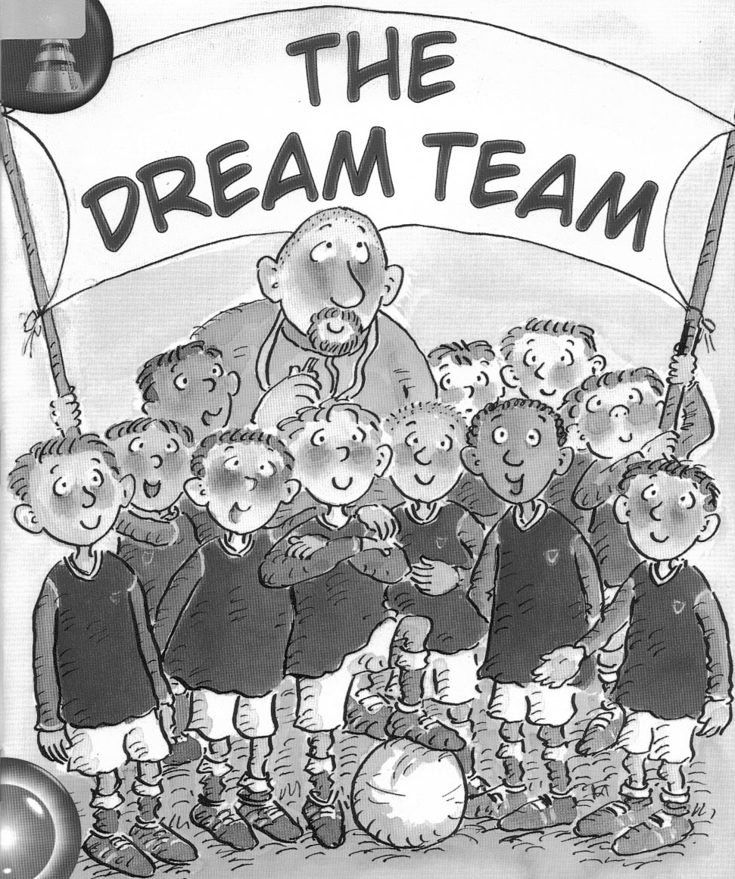

by Jane Langford

Name_____________________

(Orange Band)

Match the beginning of each sentence to the correct ending.

1. Wayne’s dad was a his ears.

2. Wayne put his fingers in doorbell rang.

3. Are you a under 10’s team?

4. He stopped talking about his football manager?

5. That night the Dream Team.

6. Would you like to manage our dreamer.

Decide whether each sentence is TRUE, FALSE or if you CAN’T TEll from the story. Tick ONE box beside each sentence.

 |  | TRUE | FALSE | CAN’T  TELL
1. | Wayne’s dad was a lorry driver.
2. | Wayne’s friends were drinking pineapple juice.
3. | Dad stopped talking about his Dream Team.
4. | Wayne was pleased his dad had stopped talking about football.
5. | Mrs Beaver from school visited Wayne’s house.
6. | Wayne’s dad got to manage the under 10’s football team.

Underline the correct word to complete each sentence.

1. Wayne’s friends came
round

up

out

bus

car

lorry
2. Wayne’s dad drove a

3. The next day Wayne had a long talk with his
gran

teacher

dog

4. Dad agreed to manage the
under 21’s

over 10’s

under 10’s

Here are some sentences about the story. Fill in the gaps using one one word or two words in each space. You may use your own words or words from the story.

Wayne’s dad dreamed of being a____________________________. Wayne sometimes got ______________________ with his dad’s dream. Dad got ________________________ and stopped talking about being a football manager. Wayne wished he had not _______________________________ at his dad. Wayne spoke to ___________________________. Mr Beaver called the house and asked Wayne’s dad to manage the _______________________. Wayne’s dad was __________________________. At last he had his very own Dream Team.

