WALT: To understand a poem and it’s features

Re-read ‘ I saw a Peacock’.

- Copy three pairs of rhyming words from the poem.

- Which words are repeated in the poem?

- Name three animals that are mentioned?

- How high was the house?

- What was the greatcoat made of?

- When did they see the Sun?

- Where was the dog?

- Draw the image you see when you read the line
‘I saw two buttons telling of their dreams’.

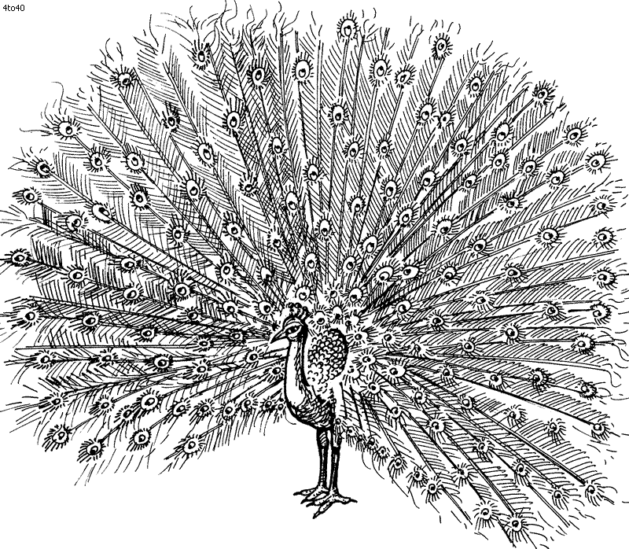
WALT: To understand a poem and it’s features.

Re-read ‘I saw a peacock’ and answer these questions in your books.

- What is repeated throughout the poem?

- What was driving the ox?

- Name 4 animals that are mentioned in the poem?

- Tell me 3 pairs of rhyming couplets.

- Why do you think King George was shut up in a box?

- How old was the butcher?

- Why was the well full?

- What is strange about the glorious sun?

- Where was the dog in the poem?

- Look at this line; ‘I saw a pack of cards gnawing a bone’. What do you think gnawing means?
Draw the image you see in your head from this line, in your books.
