Ava and Duni
Once upon a time, there was a f____rce lioness who lived in the African savannah. Her name was Ava and she was the ch___ftess of her pride. She was a great hunter but also often rec___ved gifts of food from other lions and lionesses who feared her. They would bring her p___ce after p___ce of antelope and zebra for her to gorge on. She was big and strong and w___ghed nearly twice as much as a normal lioness.
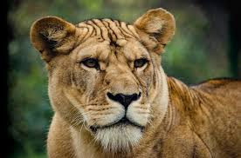
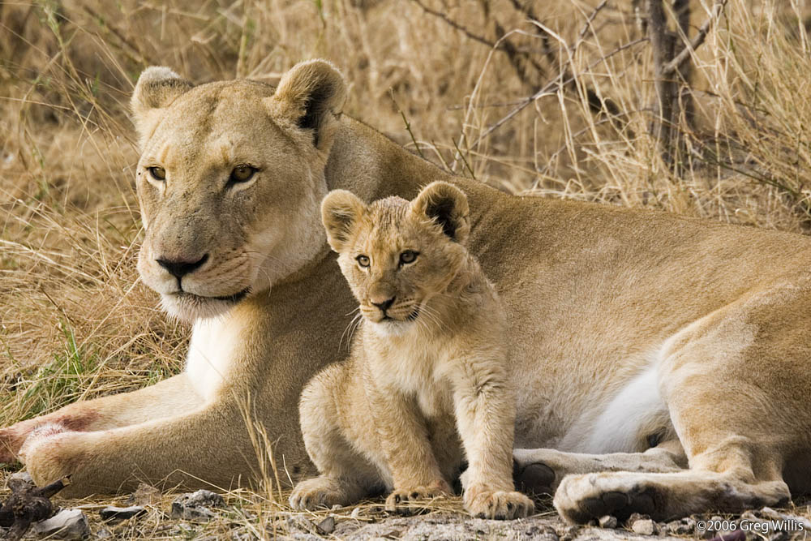
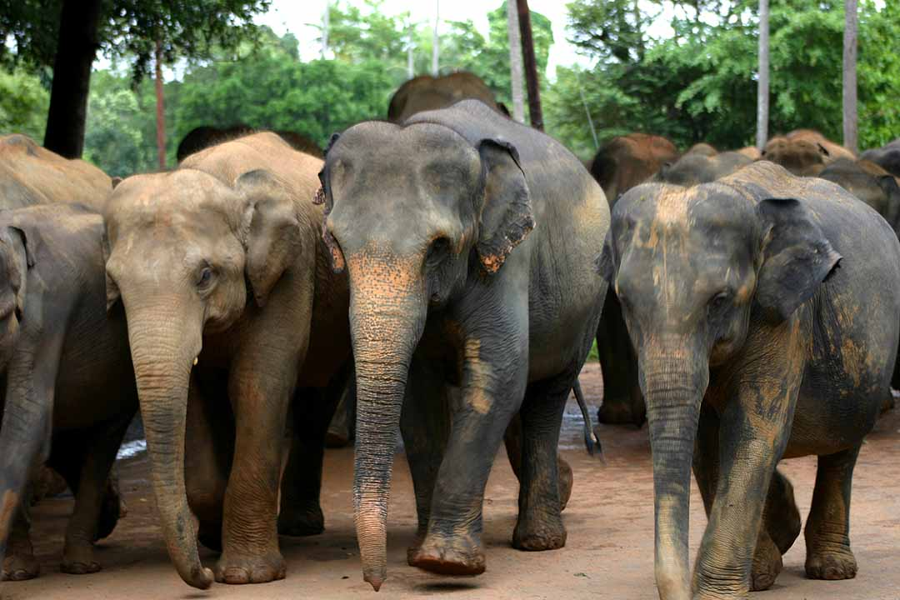

She had a young n___ce, the daughter of her sister. She was called Duni, and she was always up to misch___f. When she was ___ght months old, Duni disappeared for three days. Ava and her sister searched high and low on the savannah for her. Eventually, in desperation, they went to the elephants. With their anc___nt wisdom, they might be able to help us, thought Ava. The lionesses approached the elephant herd cautiously and asked them, “Have you seen our Duni? We’ve lost her and we’re stricken with gr___f!” The elephants thought it was w___rd that the lionesses were talking to them – normally carnivores are not fr___ndly to herbivores. But they felt sorry for them and decided to help them find th___r cub. They told the lionesses in th__r deep, slow voices, “Go to the baobab tree. At it’s h___ght you will find your cub.”
The lionesses rushed to the baobab tree and scoured the top branches – and there she was! Little Duni had made a treehouse. What a rel___f!

