Tuesday – Story Sacks 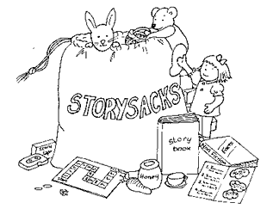

Remove all items from the Story Sack and identify what you think they are.
- Are any objects unusual?
- Do they remind you of anything?
- What do you think they are?
- Do you have any puzzles/questions?

Pretend you are an author for an imaginary world text and suggest interesting descriptions and/or actions for each of the objects.
For example:
Object = Teddy Bear – “The maroon, loveable, and soft bear trudged calmly through the wilderness.”

The adult in your group will scribe your ideas to feed back at the end.

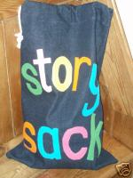

Tuesday – Fictional Paragraphs

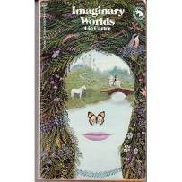

In pairs, choose a fiction text example and highlight any words/phrases the author has used to describe the setting (the place the story is set).

On A3 paper, create a mind map for each of the senses – sight, hearing, smell, taste and touch - using words/phrases that you have highlighted for each sense.

For example:

Touch = ‘crisp, dry snow under his feet.’

Add to your mind maps using the other fiction text examples.

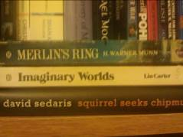

Tuesday – Picture Books

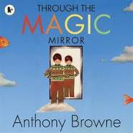

Choose a picture book and read the opening paragraph/page.

Discuss with your group and teacher – how does the author draw you, as the reader, into their imaginary world?

Think about language features, such as questioning, description, short sentences, speech…

Do they use language features, information, character description or setting description?

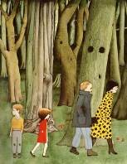

Tuesday - Gaming Perceptions

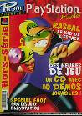

In pairs, choose a gaming magazine and choose two imaginary worlds inside that interest you (you could choose one each).

Compare and contrast these imaginary worlds using the following questions for each gaming world. Answer in your Language Skills’ Book:
- What do you see? What is happening?
- What effect does this gaming world have on you? How does it make you feel and why?
- Have you got any puzzles/questions about your gaming world?
- Find something that interests you within that gaming world – why did that particular part interest you?
- Which one of your two worlds interests you the most and why?

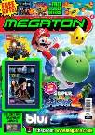
Tuesday - Artists’ Perceptions

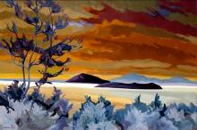

In pairs, choose your favourite and least favourite painting of an imaginary world.

Discuss with your partner why you have chosen these particular pieces.

In your Language Skills’ Book answer the following questions for your chosen imaginary world art pieces.
- Which is your favourite and why?
- Which is your least favourite and why?
- What effect does each imaginary world have on you? How do they make you feel and why?
- Have you got any puzzles/questions about your chosen imaginary worlds?
- Find something that interests you within each piece – why did that particular part interest you?

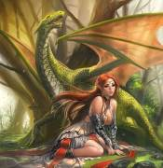
Wednesday – Story Sacks

Remove all items from the Story Sack and identify what you think they are.
- Are any objects unusual?
- Do they remind you of anything?
- What do you think they are?
- Do you have any puzzles/questions?

As a group, sequence the objects into an agreed story sequence. Agree on a story outline for your own imaginary world text.

Use the story board plan to map out the sequence of your story using the objects to help decide your plot.

Wednesday - Fictional Paragraphs

In pairs, choose a fiction text example and highlight any words/phrases the author has used to describe the characters.

On A3 paper, create a bank of interesting words/phrases that describe characters from imaginary worlds.

For example:

‘from the waist upwards he was like a man, but his legs were shaped like a goat’s…’

Add to your bank using the other fiction text examples.

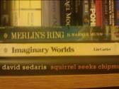

Wednesday – Picture Books

Choose a picture book in your pair.

Use post-it notes to analyse the text. Write notes on the post-it notes and stick to the relevant pages.
Note any thoughts, questions or puzzles you have.

EXT: find interesting language to describe the setting and make a bank of setting description words/phrases on A3 paper.

Wednesday - Gaming Perceptions

Choose a gaming world in your pair.

Use post-it notes to analyse the world. Write notes on the post-it notes and stick to the relevant pages.
Note any thoughts, questions or puzzles you have.

EXT: answer the following questions in your Language Skills’ Book:
- What is your opinion of these imaginary worlds?
- Do they remind you of any stories you have read/films you have watched?

Wednesday – Picture Books 2

With you teacher, read through different imaginary world picture books.

How can you tell they are based on an imaginary world from
- the pictures
- the characters
- the settings
- the use of senses?

Friday – Fictional Paragraphs

In pairs, choose a fiction text example and highlight any words/phrases the author has used to describe the setting (the place the story is set).

On A3 paper, your adult will create a group mind map for each of the senses – sight, hearing, smell, taste and touch - using words/phrases that you have high lighted for each sense.

For example:

Touch = ‘crisp, dry snow under his feet.’

Add to your group mind maps using the other fiction text examples.

Friday – Picture Books

With you teacher, choose a picture book to analyse.

Identify who the main character is and discuss how they behave in each setting.
Think about:
- Is their behaviour as you’d expect or is it affected by the setting?

Express your opinions, using the text to back up your ideas, and listen to the views of others.

Friday - Gaming Perceptions

Choose a gaming world in your pair.

Use post-it notes to analyse the world. Write notes on the post-it notes and stick to the relevant pages.
Note any thoughts, questions or puzzles you have.

EXT: answer the following questions in your Language Skills’ Book:
- What is your opinion of these imaginary worlds?
- Do they remind you of any stories you have read/films you have watched?

Friday - Artists’ Perceptions

In pairs, choose your favourite and least favourite painting of an imaginary world.

Discuss with your partner why you have chosen these particular pieces.

In your Language Skills’ Book answer the following questions for your chosen imaginary world art pieces.
- Which is your favourite and why?
- Which is your least favourite and why?
- What effect does each imaginary world have on you? How do they make you feel and why?
- Have you got any puzzles/questions about your chosen imaginary worlds?
- Find something that interests you within each piece – why did that particular part interest you?

My favourite painting is the one with _________________________________________________________________________ because _________________________________________________________________________________.

It makes me feel ____________________ because

________________________________________.

My least favourite painting is the one with _________________________________________________________________________ because _________________________________________________________________________________.

It makes me feel ____________________ because

________________________________________.

The most interesting part of all the paintings is ______________________________________. I think this is interesting because _______________

_________________________________________.

Friday - Artists’ Perceptions

In pairs, choose your favourite and least favourite painting of an imaginary world.

Use post-it notes to analyse the world. Write notes on the post-it notes and stick to the relevant piece of art.
Note any thoughts, questions or puzzles you have.

EXT: answer the following questions in your Language Skills’ Book:
- What is your opinion of these imaginary worlds?
- Do they remind you of any stories you have read/films you have watched? (Think inter-textual links).

