Improving sentences
We can improve sentences in different ways to make them more exciting, adventurous and interesting.

1. Add some interesting adjectives to describe the people, objects or places.
e.g. The man walked along the path.

The mysterious man walked along the narrow, gloomy path

2. Improve the verb(s) (doing words)
e.g. The man walked along the path.

The mysterious man crept along the narrow, gloomy path.

3. Add an adverb(s) (describe the verb)
e.g. The man walked along the path.

The mysterious man crept quietly along the narrow, gloomy path.

4. Add a clause (extra information to the sentence)
e.g. The man walked along the path.
The tall man crept quietly along the narrow, dark path, stopping every few steps to kick stones.

Look at each sentence below. Can you improve each by following each of the steps (1) to (4) above?.

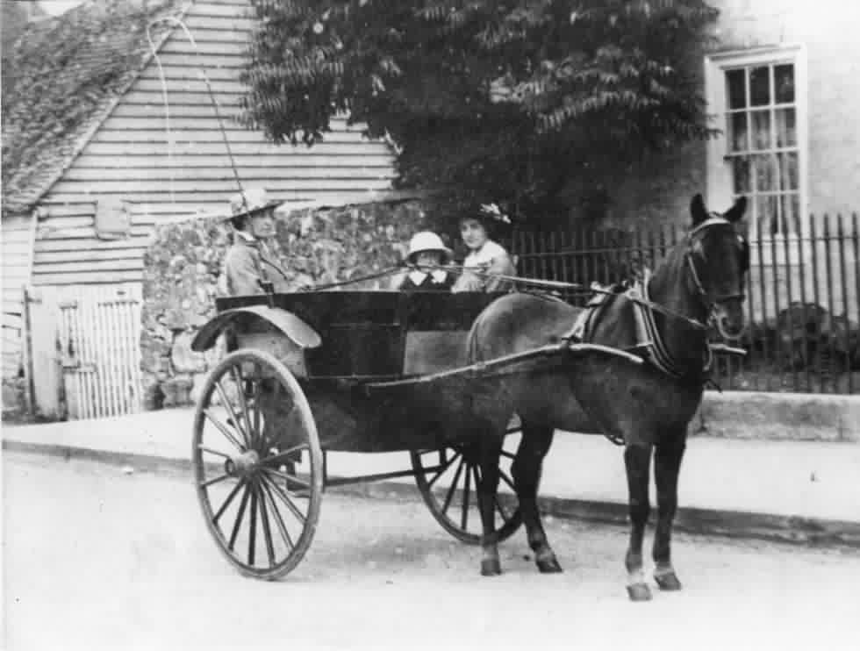
- The horse and cart clattered down the street.

- The detective looked at the clue and scratched his head.

- The graveyard was lit by the moon.

- Tim climbed up the wall of the temple.

- Jenny watched the old lady as she came closer.

- I ran back along my street, stopping when I reached Bill’s house.

- The army stood on the hill overlooking the fort.

- A storm moved over the forest.

