Jack went to sell the cow

Jack climbed the beanstalk


Jack brought golden eggs to his mum.

He climbed the beanstalk again.

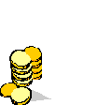
Jack stole the Giant’s coins.

The harp shouted out, “ I am being stolen”.

Jack chopped down the beanstalk.

He lived happily ever after.
Match the Pictures

