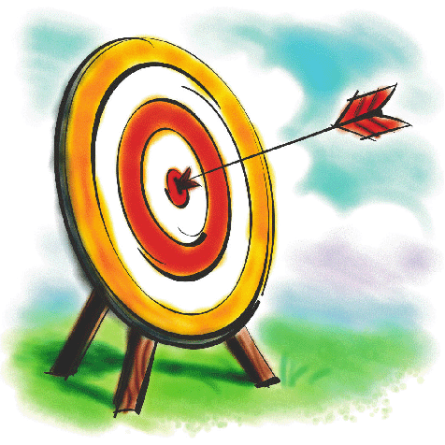
Name:
I can think about a character and write a sentence.
Behaviour:

_____________________________________________________________________________________________________________________________________
Good or bad?
_________________________
Appearance:

_____________________________________________________________________________________________________________________________________
Can you use adjectives?
_________________________
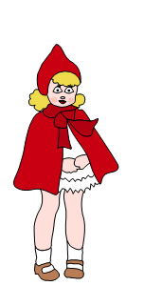
Draw something you would expect this character to do:
Goals:

____________________________________________________________________________________________________________________________________
What is this character trying to do?
___________________________________________________________________________________________
Good or bad?
_________________________
Name:
I can think about a character and write a sentence.
Behaviour:

_____________________________________________________________________________________________________________________________________
Good or bad?
_________________________
Appearance:

_____________________________________________________________________________________________________________________________________
Can you use adjectives?
_________________________
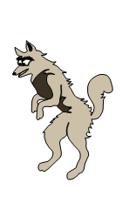
Draw something you would expect this character to do:
Goals:

____________________________________________________________________________________________________________________________________
What is this character trying to do?
___________________________________________________________________________________________
Good or bad?
_________________________
Name:
I can think about a character and write a sentence.
Behaviour:

_____________________________________________________________________________________________________________________________________
Good or bad?
_________________________
Appearance:

_____________________________________________________________________________________________________________________________________
Can you use adjectives?
_________________________
Draw something you would expect this character to do:
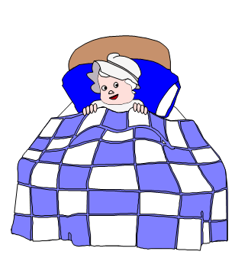
Goals:

____________________________________________________________________________________________________________________________________
What is this character trying to do?
___________________________________________________________________________________________
Good or bad?
_________________________
Name:
I can think about a character and write a sentence.
Behaviour:

_____________________________________________________________________________________________________________________________________
Good or bad?
_________________________
Appearance:

_____________________________________________________________________________________________________________________________________
Can you use adjectives?
_________________________
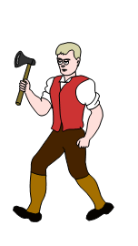
Goals:

____________________________________________________________________________________________________________________________________
What is this character trying to do?
___________________________________________________________________________________________
Good or bad?
_________________________
Draw something you would expect this character to do:

