‘lk’ and ‘nk’ Words Name ____________
Fill in the missing final blends.
su___ ri___ ba___
pi___ mi___ ta___
bu___ si___ thi___
sti___ ju___

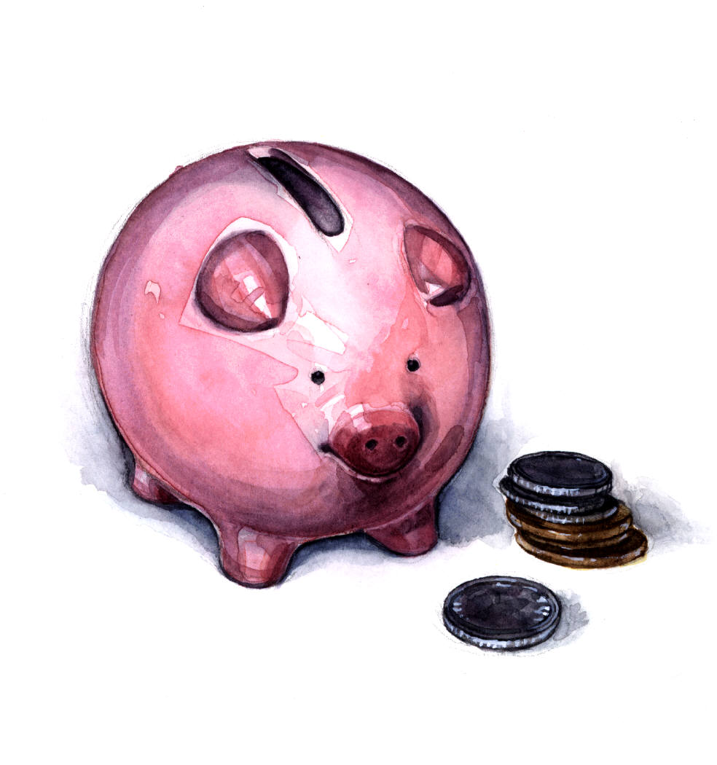

Now complete these sentences:

1. I save my money in a piggy ba___.
2. You get mi___ from cows.
3. I like to go skating on an ice ri___.
4. When I’m in a mood I su___.
5. If you mix red and white paint you get pi___.
6. I use my brain to thi___ .
7. _____________________________
8. _____________________________

