Match the pictures to the words.

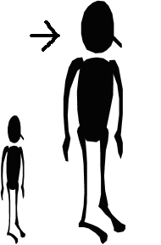
doll
hill
bell
tall
bull
wall

_all

_oll

_ull
_ell

_ill

_all

Fill in the spaces with ‘ll’ words
wall
ball
tall
doll
fall
pull
bell
shell
call
hill
will
still
small
jelly

- William kicked the ……………
- I found a ……………… on the beach.
- Humpty Dumpty sat on the ……………
- Sarah rang the ……………
- Peter is short but Bill is ……………

Can you write your own sentences with ‘ll’ words?

List words in each rhyming group

all | ill | oll | ell
wall

