Look at the front cover of the book. What do you think it is going to be about?

What do you learn about the author? Why do you think you are told about other books he has written?

The blurb on the back says “Become a superhero!” What do you think makes a superhero?

Does the blurb make you want to read the book? Why?

Now you are ready to start reading.

Read Chapter 1.
Who are the characters we meet in Chapter 1? Write two facts about each.

What happens when Mr Sloggett first puts on the slippers?

Read the description of Mr Lot’s shoe shop on pages 4 and 5. Draw a picture of the shop.

Read Chapters 2 and 3.
How does Mr Sloggett test the slippers‘ magic on the way home?

H
Mr Sloggett says, “I’m a very different person.” How? Complete the picture of Mr Sloggett below and write information on each half to describe him when he is and isn’t wearing the slippers.

Mr Sloggett wearing slippers Mr Sloggett not wearing slippers
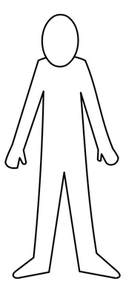

This is a simile: as quick as lightning. Find two similes on pages 12 and 13. Write two more similes describing Mr Sloggett when he is wearing his slippers. (for example: as clever as ....., as strong as.....)

On page 28 Mr Sloggett says “Let’s have fun with these while the last.” What fun would you have if you had magic slippers?

Why does Mr Sloggett ask Arthur Lot to try on his slippers?

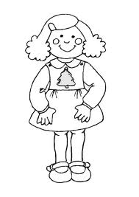
Read Chapters 4 and 5.
In Chapter 4 we meet Lollie for the first time. Write a fact file about her.

Arthur Lot sees Mr Sloggett standing on his „bald noddle“. What is a noddle?

In Chapters 4 and 5, Lollie tests how clever Mr Sloggett is in his slippers by asking him four questions. What four questions would you ask him?

Read pages 44 to 46 and then rewrite them as a playscript. Remember to write stage directions too.

Read Chapter 6.
Design an advertisement for soap powder for Mrs Sloggett to use in the Magiclean washing-machine. Remember it should be eye-catching and persuade her that it is the best!

Read Chapters 7 and 8.
In those old slippers, I suppose.
Who says this?
You haven’t told nobody about them, have you?

Right then, we’d best be getting back.
They won’t work for me.

Well, I promised to take Lollie down to the village playground while the missus looked after the shop, but she’s had to go out.
After we’ve been to the sweetshop, Uncle Percy?

Now write these as direct speech. Try to use different synonyms for said. Use a thesaurus to help you.

Apostrophes to shorten words often appear in direct speech. Write these abbreviated forms fully.

she’s ____________ ____________
we’ve ____________ ____________
we’d __________ __________
haven’t __________ ___________
Lollie just runs across the road without looking. Design a poster that teaches how to cross the road safely.

Read Chapter 9.
Write a newspaper article about the accident. You need a headline and try to include quotes from the eye-witnesses. Add an illustration with caption.

When old Sloggett puts on his slippers there’s nothing he doesn’t know and nothing he can’t do – he becomes a superhero and only a superhero can intervene when something awful is about to happen!
Your task is to become a superhero. What special powers will you have and how will you get these? Do you have a special costume? What awful event will you stop?
Draw a picture of yourself as a superhero and write adjectives around it to describe yourself the hero. Then write your own superhero story.

Design a front and back cover for The Magic Carpet Slippers.

