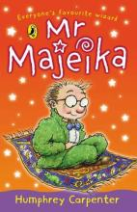
Mr. Majeika

Chapter 1 – The Carpet-Bicycle

Finish the sentences

- Class 3 were in a bad mood because
- Class 3 were in a bad mood because
- Class 3 were in a bad mood because
- Melanie cried first because
- Mr. Potter was cross because
- Everyone stared at Mr. Majeika because

Chapter 2 – Chips for Everyone

True, false or can’t tell?

- Class 3 were noisy for the rest of the lesson.
- Everyone was thinking about the magic carpet.
- They had rich tea biscuits at break.
- Wim was eating a chicken flan.
- Wim was four years old.
- The school did not allow chips.

Chapter 3 – Hamish Goes Swimming
Match the halves of the sentences.
- Nothing strange happened
- Hamish was not
- He was rude to Melanie
- Mr. Majeika pointed at Hamish
- Mr. Majeika had turned
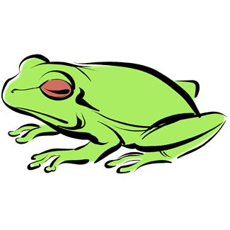
- Mr. Majeika didn’t know
behaving well.
and he vanished.
how to turn him back.
and made her cry.
for weeks and weeks.
him into a frog.
Chapter 4 – The Frog’s Princess
Change one word to make the sentence correct.
- Mr. Potter stayed at the school all night.
- Hamish was still a toad in the morning.
- They decided he should be hugged by a princess.
- They made a throne out of a table.
- Pandora kissed the frog.
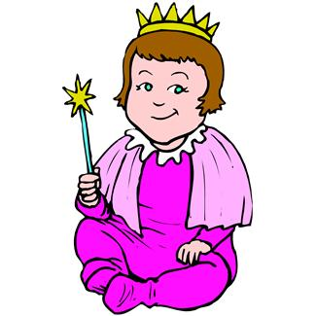
- The frog turned into Thomas.

Chapter 5 – The Disappearing Bottle
Sort out the muddled sentences.
- children to The had Superman.
been see
- wanted someone to fly. They see
- Mr. in brought potion. Majeika a
- sticky. was potion green The and
- were soon The floating class about.
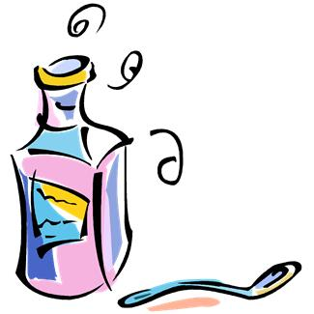
- of The had potion vanished. bottle

Chapter 6 – Mr. Potter Goes for a Spin

Write out the sentences in the correct order.

Mr. Potter began to float.
Mr. Majeika opened the classroom windows.
Hamish went to get Mr. Majeika a cup of tea.
The class pretended not to notice.
The weather began to warm up.
Mr. Potter drank the tea.
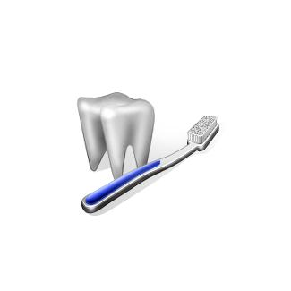
Chapter 7 – Dental Problems
Fill in the missing words. Find them in the book.
- A ________ was coming to the school.
- Hamish was making fun of Melanie’s ________.
- Mr. Majeika turned his teeth into __________ teeth.
- Hamish had to wear a ________ over his mouth.
- The dentist gave a ________ when she saw the teeth.
- Hamish had to be ________ to make the teeth go away.
Chapter 8 - Hamish the Good
Who said these things?
- I want you all to enjoy your holidays, said ___________.
- Don’t overdo it Hamish, said ________.
- Will you be here next term? asked __________.
- That boy is giving us the creeps, said ________.
- Don’t you think they’re pretty? said _________.
- So that’s what he was up to, said __________

