no
go
so
going
home
joke

nose
rope
note
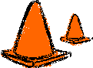
cone
throne
smoke
old
sold
gold
most
don’t
both

know
show
own
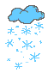
snow
grow
slow

goal
boat
coat
foam
soap
loaf
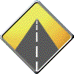
road
goat
Joe
toe

