Cut out the pictures and the words and match them together!
book | 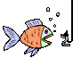
moon | 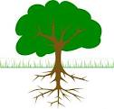
pool | 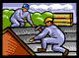
root | 
roof | 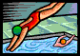
hook | 
school | 
tool | 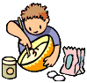
cook | 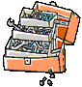
look | 