Cut out the pictures and the words and match them together!
book
moon | 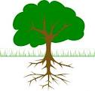
pool
root
roof
hook
school
tool
cook
look

