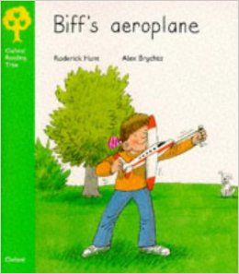
Title: _______________________

Who made an aeroplane?

Where did she take it to fly it?

Who helped her to make it?

What three colours are the aeroplane?

What two things did the plan fly over?

What happened to Biff’s aeroplane when it landed?

Who helped look for the aeroplane?

Where did Biff go when she couldn’t find the aeroplane?

How did she feel when she couldn’t find it?

What happened at the end of the book?

Did you like or dislike this story? Why?

Draw Biff and her aeroplane.

