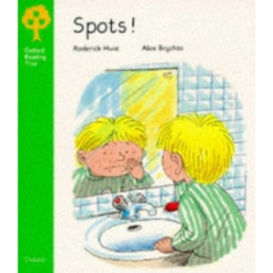
Title: _______________________

Who has spots?

Who else had spots?

Who came to look at the children’s spots?

Did Mum or Dad have spots?

Who looked after everyone?

What two jobs did he do?

What did Mum say when she saw Dad?

What was wrong with Dad?

Kipper had ________________ | Biff and Chip had spots, too.
The _________________________ came. | “__________________________________________________________,” she said.
_________________________ had spots. “Stay in bed, too” said the doctor. | _________ ___________________  after everyone.
___________________________

He put _____ ___________________ out. | He went _________________________.
“What a job!” ____________ _________. | Everyone ____________ _______________.
“ _______________________!” said Mum. | ___________________________________.

