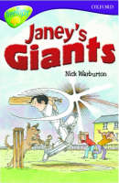
Janey’s Giants

Why is Mr Such angry? (p6 2 reasons)

Mr Such is angry because

What is Freddie’s team called?

Freddie’s team

Why does nobody want to join Janey’s team?

Find the words that mean the same as

Unhappily (p15)

Looking angrily (p19)

Said under his breath (p18)

Moved quickly (p25)

What simile on page 24 tells you Freddie was moving very fast?

How many points did the Giants need to win?

They needed

Why was Freddie “snorting and stamping and showing his teeth?” (p26)

Fast Freddie was

Find 6 words in the story that are better words for walked

Look at the description of Brian on Page 28. Draw him as accurately as you can.

What can Freddie not believe at the end of the story? Why?

He can’t believe that

