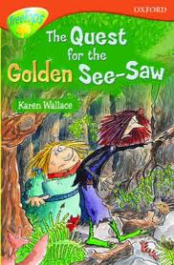
The Quest for the Golden See-Saw
- What phrase on page 5 tells us that King Codger looks very old?
The phrase
- Why did King Codger’s wife Queen Hundridwate die?
Queen Hundridwate died because

- Find a word that means the same as
looked (p18)
hit (p21)
made fun of (p24)
said quietly (p27)
- What does “You could have heard a goblin sniff” mean? (p32)

- What 2 phrases on page 34 tell us that Wolverina is angry?

- How many days were Goldie-Ox and Wolverina on the quest for?

- Copy 3 sentences on page 38 that tell us Goldie-Ox wants to give up.

- Find the simile on page 44 and write it here.

Draw the setting described on pages 46 and 47 as accurately as you can.

- How does Goldie-Ox get across the lake to the Golden See-Saw?

- In Chapter 6 there are lots of different words for said. Can you unscramble them?
dprleie
tmerudet
dksea
rcdei
hdrswipee
udrmumre

