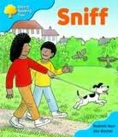
Sniff
Will you after Sniff? Mrs May.
Sniff in the mud.
“I am ” said Wilf. “I a rest.”
were fast asleep.
hot said They
went look want

Find a word that rhymes with
fun
dark
log
mat
call
Draw the pictures

Sniff ran after a duck. Sniff jumped in the pond.

