Songbirds Stage 6 Clare and the Fair

- Find a word that rhymes

page | word | rhyming word in book
3 | hair
4 | found
8 | stood
10 | fight
13 | stare
15 | flare
20 | jackets

- Read each sentence and draw a picture.

Children flying around with wind in their hair. | Winning a fairy and winning a bear. | Cornflakes spilt all over a chair.

- Colour in all the words that rhyme.

Clare | ground | air
you | fair | scare
jam | didn’t | chair
there | hair | look
stare | packets | bear

- What would you do at a fair? Tick what you would like to do.

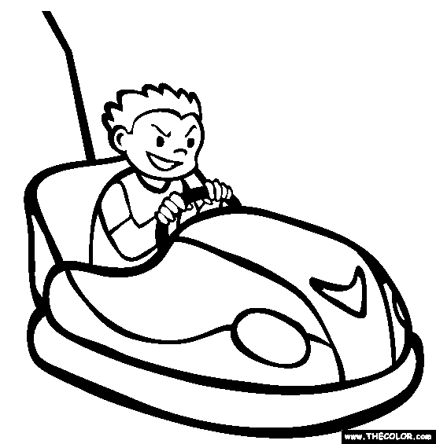 | 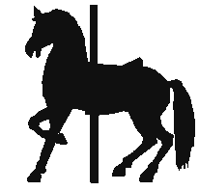 | 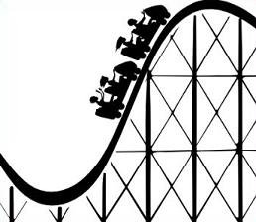
dodgems | carousel | rollercoaster
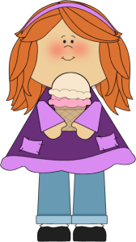 | 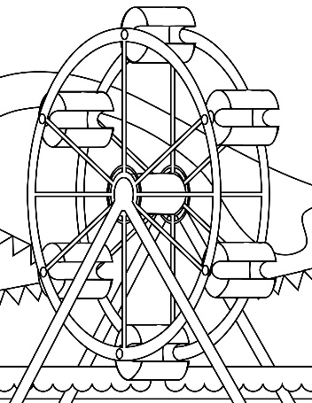 | 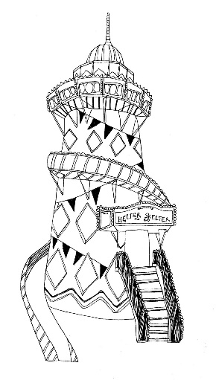
eat ice cream | big wheel | helter skelter

