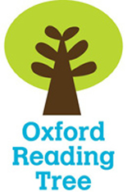
Name _____________

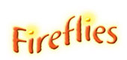
Food as Art

Stage 6

My reading book is called _____________________
The author is ____________________
I think I am going to learn about_________________
__________________________________________
- Look at the Contents page.

Write down which page you will find out about -

Page
Cheeseburger
Pasta jewellery
Profiterole
Popcorn
Chewing gum
How to make playdough
Index

- Fill in the missing words from the introduction.
photographs decorate draw sculptors used

Many artists often _________ or paint food.
Photographers take ________________ of food and ______________ make sculptures using food. Food can also be ___________ to make art. Chefs bake and ___________ food.
a b c d e f g h i j k l m n o p q r s t u v w x y z

- Put these words in alphabetical order.
apples potatoes raisins
_____________, _____________, _____________
gingerbread vegetables popcorn
_____________, _____________, _____________

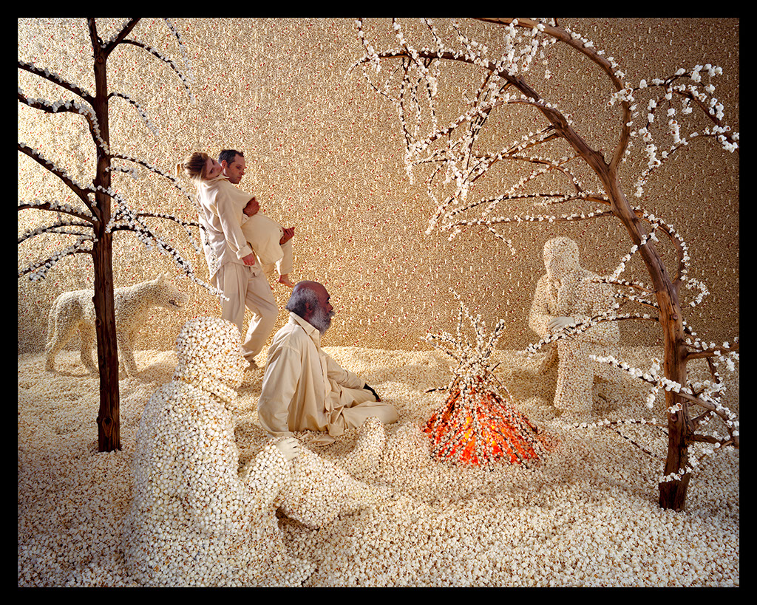
- Look at the ‘Raining Popcorn’ picture on page 6.

Write 4 nouns you see -
____________
____________
____________
____________

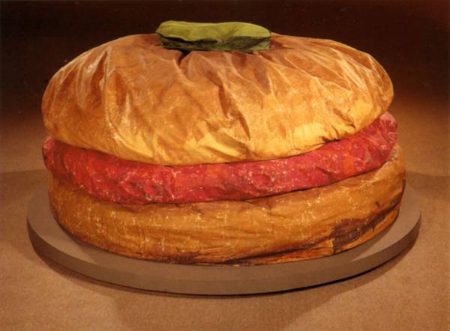
- Look at the ‘Floor Burger’ picture on page 10.

Write down 3 facts about it -

1. ______________________________________

2. ______________________________________

3. ______________________________________

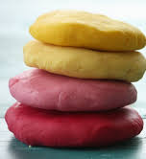
- Read the instructions about how to make playdough.
- Put these instructions in the right order by numbering them 1 - 4.

Add some food colouring to warm water and stir into the flour mixture.
Roll out the dough onto a flat sheet and cut out shapes.
Put the flour, salt and oil in a bowl and mix everything together.
Add enough water to make a soft dough.

- Look at the Index on page 24.
Write down which pages you will find out about -

Pages
sculptures
vegetables
food
popcorn
artists
shapes

