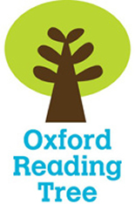
Name _____________


Tour de France

Stage 6

- Look at the Contents page. Complete the table.

Page
About the Bikes
3
Prizes
A Tour de France Winner
24
The Course

- Using p13 label this bike correctly.

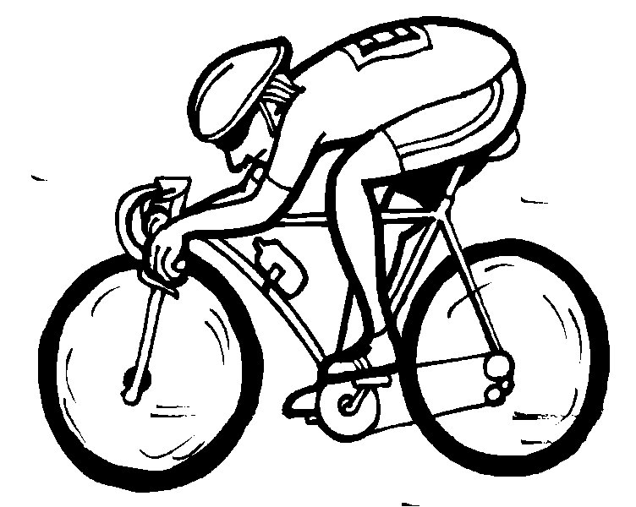

- Can you find the proper nouns in this book? Proper nouns are names of places and people.

- Use your book to find the correct information. Colour each statement to match the correct colour of jersey.

the fastest rider up the mountains

the rider with the most points for the sprints

the fastest rider under the age of 25

the leader of the race wears at the start of each day

