The Owl Who was Afraid of the Dark

Name:

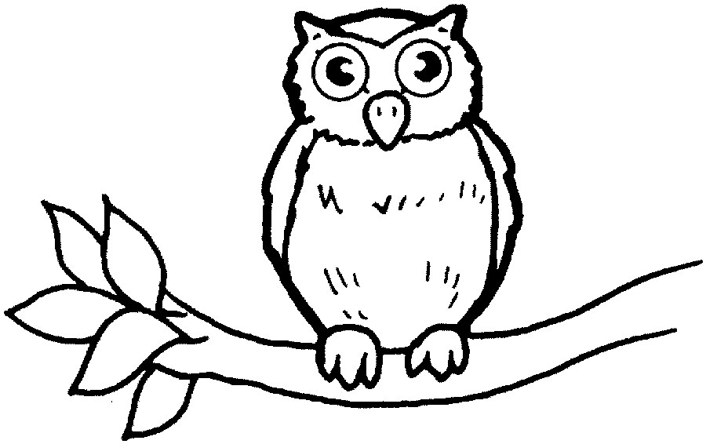

Find out what colours to use by reading the story.

Complete the sentences. You will find the answers in the story.

- Plop was a baby___________.
- He lived with his _____________ and _________.
- They lived in a very tall_____________ in a field.
- Plop was fat and_____________.
- He had ____________round eyes.
- He had knacketty_____________.
- But he was afraid of the _____________.

2. Are you afraid of anything? Draw a picture of it.
I am afraid of …

Now, ask 2 friends what they are afraid of.
1_______________ is afraid of _____________________
______________________________________________

2_______________ is afraid of______________________

3. Plop lives in a nest hole. Where do these animals live?
Join them up.

Plop nest hole
horse kennel
rabbit stable
pig hutch
dog pig sty

4. Fill in the missing words
1. Plop said “Dark is _________________.
2. The little boy said “Dark is _______________.

Nasty exciting

5. Who is the author of the book?

- Who is the illustrator?

7. Can you find Plops tree?
There is a bush at the bottom of the trunk. Plops nest hole is near the top. There is a kite stuck in the branches. The squirrels have their home in the trunk.
I think Plops tree is tree______.

Colour the pictures.

- Tick the correct answers.

- Plop said “I can’t hear”
Plop said “ I can’t see”

- He had a mouse for dinner.
He had a rabbit for his dinner.

- The old lady was in the garden.
The old lady was in the house.

- The old lady said “Dark is sad”
The old lady said “Dark is kind”

- She liked to remember.
She liked to forget.

- Plop was snoring because he was_______________.

- Who lived in the tree with the owls?
____________________________________________

- What did the little girl have in her hair?
_________________________________________________
______________________________________

- Complete the following sentences.

- Plop ____________ up his daddy.
- Plop thought the lady was ________________.
- The lady was___________________in a book.
- The rocket firework went_________________.
woke drawing spoke reading Father Christmas snowman
whoosh bang

- What did the little boy think about the dark?
_______________________________________________

- Can you write down the names of the fireworks on pages 10
and 11?

Read ……..Dark is Fascinating, Dark is fun, Dark is necessary to find these answers.

- Complete the sentences.
- Plop watched the __________________ build the fire.
- The boy scout said “Dark was _______”
- The scout knew that owls swallow their food _________.
- Plops parents began to get ____________ when he wanted to talk to them during the day.

Read Dark is Wonderful to find the answers to these questions.

- What is the name of the contraption the man was looking
through?

- What did the man think Plop was, when he landed next to
him?

- How far away was the star that Plop could see?
______________________________________________________________________________________________

- Plop became a real ___________owl, when he slept all ___
day __________.

Read Dark is beautiful

- What was the name of the cat?
____________________________________________
- Finally, what does Plop think of the dark?
_______________________________________________

