oy / oi

Put in the correct spelling
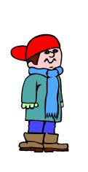
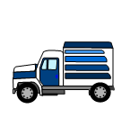

1. A __________ car. (toy / toiy)

2. A kettle is used to ________ water. (boil / boyl)

3. My wellies were covered in ________. (soil / soyl)

4. Come and _________ in with our game. (join / joyn)

5. I was so happy I jumped for _______. (joy / joi)

