Past Tense
name _________________
I walk . I walk _ _ .

I talk. I talk _ _ .

I jump. I jump _ _ .

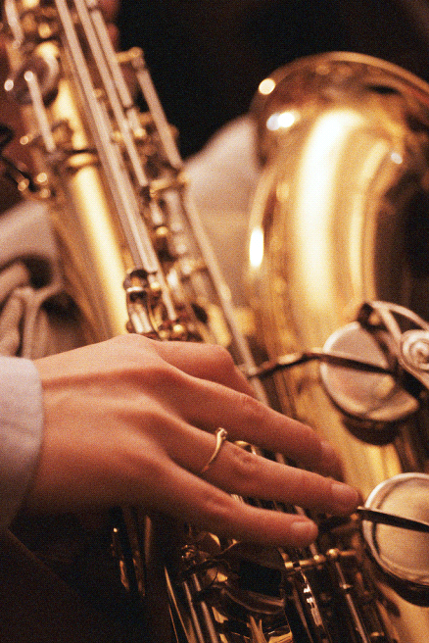 I play. I play _ _ .

I stay. I stay _ _ .
I climb. I climb _ _ .

I ski. I ski _ _ .

I bowl. I bowl _ _ .

I bat. I batt _ _ .

I kick. I kick _ _ .

