

I have used rhetortical questions…
I have used connectives to explain my ideas.
Persuasion

I have included informal language.
I have used repetition.
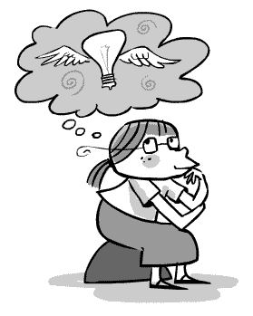
I have used adjectives to describe feelings and emotions.
I have used exaggeration.
I have appealed to an emotion.
I have used interesting openers.
Most people would agree that…
Only a fool would think that…
A sensible idea would be to…
Doesn’t everyone know that…?
The REAL truth is that…
The fact is that…
EVERBODY knows that…
Surely you would agree that…
Here are two reasons why…
This clearly shows that…
We can see from the evidence that…

