Character Description

In your traditional tale you will need two main characters – the ‘goodie’ and the ‘baddie’.
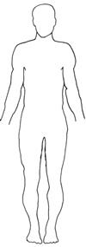
He or she likes to:
He or she is bad at:
He or she likes to:
He or she is good at:
Good Character.
Name:
Adjectives to describe good character:

Things she or he does to prove they are good.:

Bad Character.
Name:
Adjectives to describe bad character:

Things she or he does to prove they are bad.:

Planning your traditional tale.

All traditional tales follow a similar pattern. Fill in this plan using the two characters from your previous work.

