Guided Reading Planner Year Group:
1
week beginning: term Teacher: IW/ Guided reading
Reading Focus Group | WALT – Read with fluency and intonation  AF reference – AF 1 | WILF - use punctuation to read fluently  Use intonation to match action and punctuation
Group –  Teacher -  Band – Brown  NC level 3c/b  Book – Attack of the X-Bots  Week 1 | IW: Use direct speech  Continue the story of The X-bots Are Coming! Use direct speech in the story, use “ “ and punctuate before second speech mark, new line new speaker.  Book introduction – Attack of the X-bots Look at pictures of the different X-bots and the differences between them. How have they changed and improved? Which X-bot is Rover most like?  Recall last event in X-bots Are Coming.  Read pages 2 and 3 together and Q.1 recap the details of the traps the micro friends set. Q.2 What else could offer protection? (water, walls)  - Strategy check – How can you help yourself? - decode – sound talk/pic clues/chunk/re-read/read on-using context/ record on whiteboard to check later  - Independent reading - Children to read around the table one at a time encouraging finger pointing for 1:1 correspondence.Focus AF1 Read to end of chapter4  - As read, consider the changing emotions of the friends and Dr X as the attack occurs.  - Returning to the text: Q.3 Why did the friends decide they must fight the X-bots?  - Q.4 What defences have the children used?  - Q.5 What was the outcome of each?  Next steps –  Next week - Describe what has happened up to the end of chapter 4 using the correct order (AF 2)

Guided Reading Planner Year Group:
2
week beginning: Teacher: Guided reading / IW
Reading Focus Group | WALT – Identify actions and words that reveal a character’s personality  AF reference – AF 3 | WILF - identify punctuation, actions and vocabulary that shows how a character feels  Explain the effect each has upon the reader.
Group –  Teacher -  Band – Brown  NC level 3c/b  Book – Attack of the X-Bots  Week 2 | Book recap – Attack of the X-botsChildren will have had time to have read chapters 4 and 5 during the week. Pick up from page30  Q. 1What has happened so far? (pike – burst inflateables, water catapult knocked out flying x-bots, moles – fell in holes – bubble gum trap, magnet made them break, Max is trapped, Cat has idea and takes off in boat)  Q.2 Why do you think Cat left the others at the end of chapter 6?  - Strategy check – How can you help yourself? - decode – sound talk/pic clues/chunk/re-read/read on-using context/ record on whiteboard to check later  - Independent reading - Children to read around the table one at a time encouraging finger pointing for 1:1 correspondence.Focus AF1 Read to end  - As read, ask children to think about how the character’s words and actions reveal their personalities.  - Returning to the text: Q.3 What were all the traps set by the children? ( bread/ducks, holes bubble gum, magnet, water ballon catapult)  Look back from the start of chapter  Q. 4 What do Ant and Tiger think Cat is doing when she leaves the castle? (running off, abandoning them)  Q.5 Do you agree or disagree with the way they reacted to her leaving – why?  Q.6 Why does Max jump down from his sate place in the tree?- (p39) (wanted to help his friends)What does this tell you about his character?  Q. 7 Do Dr X and Plug and Socket have the same feeling about the attack?Why?(p45) (No – Dr X upset/angry – P & S happy – could get old jobs back)  If child cannot answer allocated question- note this and record suggestions from other children.  Q.8 What defences have the children used? oral –recorded in iw  - Q.9 What was the outcome of each?  IW: complete problems and outcomes sheet  Next steps –  Next week – new book, dramatise last 2 chapters of Attack of the X-bots.



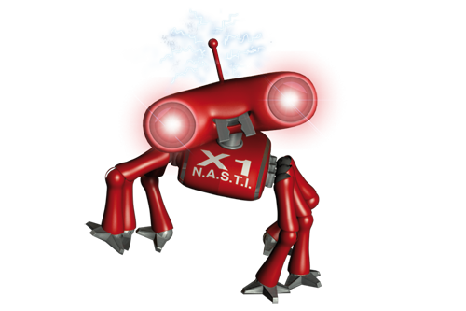
Attack of the X-Bots Attack of the X-Bots

