Guided Reading Planner Year Group:
1
week beginning: term Teacher: IW / Guided reading
Reading Focus Group | WALT – identify different ways information is presented. identify key features of information presentation and show an example from the text  AF reference – AF 4 | WILF - identify different ways  Provide examples to show each
Group –  Teacher -  Band – Brown  NC level 3c/b  Book – Dr X’s Top 10 Villians  Week 1 | IW: complete problems and outcomes sheet  Book introduction – Dr X’s Top 10 Villains look at sheet of mixture of heos and villains. How many do the children know? Which are heros? Which are villains? Q. 1 What characteristics do heros have? (kind, brave helpful) Q.2  What charcteristics do villains have? ( mean, selfish, dangerous, out for themselves) Who are children’s favourite villain?  Skim through the book to find out which villains Dr X has chosen and compare these with childrens choices. Are there some the children have never heard of?  Look at Darth Vader section together, draw attention to way info presented. Read biography on p4. Discuss features of style used –heading, paragraphs in chronological order, picture with caption. Ask children to read p5 in pairs. Discuss what they know about Darth Vader Q2 – record knowledge, note who can/can’t recall.  - Strategy check – How can you help yourself? - decode – sound talk/pic clues/chunk/re-read/read on-using context/ record on whiteboard to check later  - Independent reading - Children to read around the table one at a time encouraging finger pointing for 1:1 correspondence.Focus AF4 Read to end of p7 ask them to look at the different ways information is presented  Returning to the text: Q.3 Name 2 things which the villains on pages 3-7 have in common (darth vader and Dt Ivor Eggman – half man half robot/cyborg, both want to take overother worlds, both have other names,born different planets )  Q.4 Name 2 differentces pages 3-7 (one injured in fight, one accident, one sorry, one not, )  Q.5 Which villain is most evil? Why?  Divide into 2 groups and give postits. Each group to focus on one of the villains. Give a few minutes to read again, then write comments about the way the information is presented. (AF4) Make comments in focus children box as to whether can identify features ( Darth - heading, paragraphs in chronological order, picture with caption. Eggman – illustration, profile listing facts, paragraphs in chronological order. Headings)  Next steps – Next week –

Guided Reading Planner Year Group:
2
week beginning: week term Teacher: IW / Guided reading
Reading Focus Group | WALT – identify different ways information is presented. identify key features of information presentation and show an example from the text  AF reference – AF 4 | WILF - identify different ways  Provide examples to show each
Group –  Teacher -  Band – Brown  NC level 3c/b  Book – Dr X’s Top 10 Villians  Week  Session 2 | Book recap – Dr X’s Top 10 walk briefly through the book again to the end of page 9. Comment on the villains who are profiled. (Dr. Ivo Eggman, Darth Vader Clarify vocabulary – robotics, chemistry, cloning, biology p.13 and toxin p22. Talk about choices in reading, being able to hold a conversation about what has been read and giving reasons for opinions.  Each child can choose a villain to read about and have time to prepare a talk about how good/bad a villain they are, backed up with quotes from text.  Ask children to choose villain to become an expert on and give a talk about from pages 8 to 29  Strategy check – How can you help yourself? - decode – sound talk/pic clues/chunk/re-read/read on-using context/ record on whiteboard to check later  - Independent reading - Children to read around the table one at a time encouraging finger pointing for 1:1 correspondence.Focus AF6 Read to end of p7 As children read, have them jot information/ vocabulary used to describe their villain.  Returning to the text  Ask children to tell a partner about the villain they have read about and what they have learned.  Q.1 What effect do powerful vocabulary choices have on the reader?  Q.2 How did the way the informations was presented help/hinder the reader? Which did they prefer?  IW: Use powerful vocabulary to describe a new super villain.  Next steps – stay on same level  Next week –

Guided Reading Planner Year Group:
3
week beginning: week term Teacher: IW / Guided reading
Reading Focus Group | WALT discuss reasons for choices giving reasons to support choices  AF reference – 2 use quotes from the text to support answers | Choose favourite villain  Explain why this is your choice  Support your choice with quotes about them from the text
Group –  Teacher -  Band – Brown  NC level 3c/b  Book – Dr X’s Top 10 Villians  Session 3 | IW: Use adjectives to describe a hero.  2 adjectives and a noun  Book recap – Dr X’s Top 10  - What villains did the children choose to read about last week? Each target child to feed back some facts. Read selected pages between pages 9 and 32 independently. As reading, hear one or two read (AF1) As reading, children to note any unusual words and record on whiteboard for discussion.Children to choose acharacter they did not read about last time. As they read, ask them to think about details that make the villain interesting  - Strategy check – How can you help yourself? - decode – sound talk/pic clues/chunk/re-read/read on-using context/ record on whiteboard to check later  Independent reading - Children to read around the table one at a time encouraging finger pointing for 1:1 correspondence  .Focus AF2 Use quotes from the text to support answers.  - Returning to the text: discuss any vocabulary jotted down.  Q.1 Which villains did you find the most interesting and why? Quote from text to support answer  Q.2 Which villain did you find the least interesting? Why? Quote from text to support answer  Q.3 Create questions you could ask an expert on your favourite villain. (record an example on here) Children to write on post its to put in book. WALT: create questions based on a text.  NEXT: IW children becom quiz masters to answer questions planned today

Dr X’s Top Ten Villains
WALT: use adjectives
Create a super villain.
What powers will your villain have?
What will he/she look like?
Create sentences to describe your villain.

Use 2 adjectives before a noun. Remember to put a comma between your adjectives.
WAGOLL:
Plant Man
Plant Man is a powerful, evil villain. He has short, emerald green hair. His arms can become long, spiky branches.

Dr X’s Top Ten Villains
WALT: use adjectives
Create a super villain.
What powers will your villain have?
What will he/she look like?
Create sentences to describe your villain.

Use 2 adjectives before a noun. Remember to put a comma between your adjectives.
WAGOLL:
Plant Man
Plant Man is a powerful, evil villain. He has short, emerald green hair. His arms can become long, spiky branches.

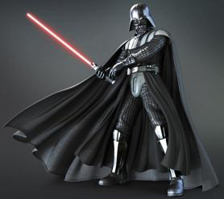

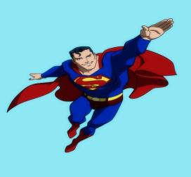
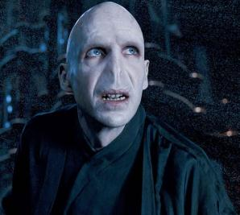

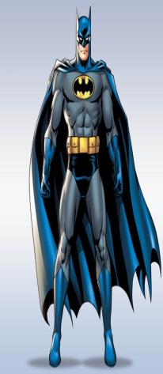
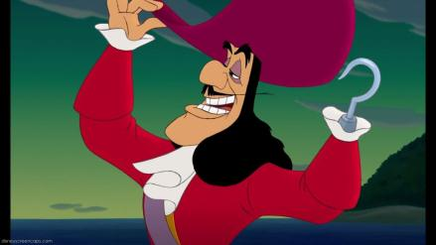
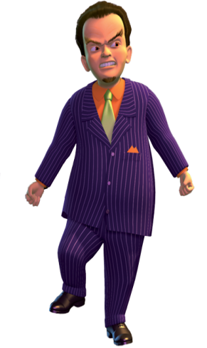
Dr X’s Top 10 Villains

scary fierce animation tantrum mutant invasion warped prophecy genes modification
scary fierce animation tantrum mutant invasion warped prophecy genes modification
Date: ______________
Dr X’s Top Ten Villains (3c/b)
WALT: Locate information in a text.
From the text, plan 5 questions that someone could answer by reading it.
Note the answer to your question and the page it can be found on.
My Questions | Answer | Page
Put the name of the person whose questions you are answering
__________questions | Answer | Page
1
2
3
4
5

