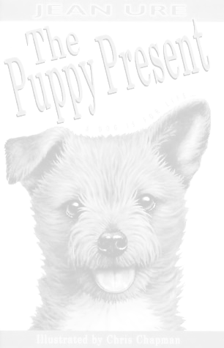
The Puppy Present.

Chapter One.

1. How many pups were born together?

2. How many were boys and how many were girls?

3. What was the name of the mother?

4. What type of dog was the mother?

5. Where did the puppies live?

6. Who had a baby brother?

7. What sort of noises did James’ parents make over his pram?

8. How old was James?

9. What bad thing did James do?

10. Why did he do it?

Punctuation.
Put in capital letters and full stops and one exclamation mark!

he stomped down the path and found a big stick then he stomped back up again and slashed with the stick at mum’s flowers that would teach her now she would have to take notice of him

Draw a picture of the puppies here.
Chapter 2.

Fill in the gaps

1. When they were weeks old, , and his .
and were turned out of their nice cosy .
2. Ginger’s mum was called .
3. Puppies were so .
4. It was time they went to new .
5. She was taken for a good long walk in the .

Ginger homes ten brothers exhausting sisters Lucy park

1. What does the word exhausting mean? Use a dictionary to help you.

2. Can you think of another word which means the same thing? Use a thesaurus to help you.

3. What does the word cuddled mean? Use a dictionary to help you.

4. Can you think of another word which means the same thing? Use a thesaurus to help you.

Chapter 3.

Vowels

The letters a,e,i,o, and u are called vowels.

- Underline the vowels in each of these words.
- Split each word into two parts and keep a vowel in each part.

Thoughtfully thought fully
himself ____ ______
something ____ ______
everyone ____ ______
thoughtfully ____ ______
trodden ____ ______
herself ____ ______
bedroom ____ ______
television ____ ______

Can you unscramble the words that we use at Christmas.
erptesn
utkrye
rcakscre
oBgnix aDy
erte
agesm
Here are two examples can you find the rest yourself

present crackers

1. “Rub his nose in it and chuck him in the garden”

What do you think of this statement?

2. Do you think it is fair to treat a dog this way?

3. Do you think Ginger will be happy living with Maisie and her family?

Draw a picture of Ginger.
Chapter 4.

Put these sentences in the correct order. Don’t forget to use capital letters and full stops.

- Nothing to do with the baby.
- It was his Christmas tree.
- His very own.
- The baby was too young for Christmas trees.
- James Colin had a Christmas tree all covered in spangles and sparkles and ropes of tinsel.”

_______________________________________________________________________________________________________________________________________________________________________________________________________________________________________________________________
Punctuation.
Put in capital letters and full stops, one question mark and one exclamation mark!

his mum was telling fibs the baby couldn’t buy james a present it didn’t have any money, for one thing; and for another, it couldn’t walk or talk so how could it possibly go out an buy anything

Chapter 5. In Training.

1. What happened to Ginger when he was a bad boy?

2. Why did Ginger not go for walks?

3. Where did Ginger bury his doggie biscuits?

4. Who did not pet Ginger?

5. Why did everything change for Ginger?

6. How did Ginger feel when he was left on his own?

7. What did Maisie’s mum do to Ginger when she got home?

8. Do you think the way she treated him was fair? If not why not?

9. What did James do that was naughty?

10. Why was James being naughty?

Chapter 6.

This chapter is very sad for Ginger. In your own words describe what happened to him.

Chapter 7.
Punctuation
Put in capital letters, full stops and one exclamation mark!

james colin was running away from home he had made up his mind nobody loved him any more all they cared about was the baby dad had said to him at breakfast, “i’m warning you, my boy i’m not going to tolerate much more of this sort of behaviour “

Fill in the missing words.

Now it was o’clock and Dad was in the , serving customers. Mum was in the , sorting boxes. It was then that James : he was going to away. He would run as far and as as he could and they would never see him . Then they be sorry!

Would nine shop decided again fast storeroom run

Draw a picture of the things James put in his plastic bag.

Chapter 8.
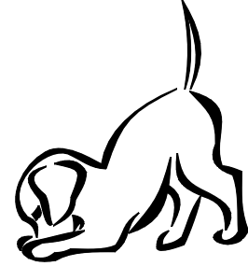
Wordsearch

P | O | P | H | J | D | A | D | C
U | A | S | H | A | Y | Q | C | H
P | G | S | L | M | U | M | R | R
P | R | E | S | E | N | T | U | I
Y | E | N | W | S | P | B | E | S
L | G | D | J | R | S | V | L | T
J | N | N | R | Q | A | Z | T | M
U | I | I | R | L | D | O | Y | A
L | G | H | A | P | P | Y | Z | S

Can you find these words? Cross them off as you find them.

puppy present Christmas James Ginger Mum Dad

kindness cruelty happy sad

1. Why did James’ mum not let Maisie’s family take Ginger home?

2. Would you have let them take Ginger away?

3. Was there anything you liked about this book?

4. Was there anything you disliked?

5. Has anything that happens in this book ever happened to you?

6. What will you tell your friends about this book?

7. Which part of the book stays in your mind the most?

