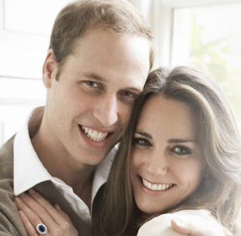
Wednesday 27th April
I can use commas to separate additional information.
Add the commas using a pencil. Write the sentences in your book neatly.

Prince William and Kate who were college sweethearts are due to be married this week.

Prince William aged 28 is a pilot with the Royal Air Force.

William’s father who was Prince Charles married Lady Diana Spencer.

Prince Henry of Wales commonly known as Prince Harry is the younger brother of Prince William.

Prince Charles William’s father has said that he is "thrilled" by his son's engagement.

Westminster Abbey where Kate and William will marry is one of the world’s greatest churches

Prince Harry who is William’s brother will be his best man.

Pippa Middleton who is Kate’s sister will be her maid of honour.

Kate Middleton who is very fashionable will wear a wedding gown fit for a princess.

Can you make up any more sentences using commas to separate a list of actions?

Wednesday 27th April
I can use commas to separate a list of actions.
Cross out the words you don’t need, add the commas using a pencil. Write the sentences in your book neatly.

Kate and Prince William enjoy ski-ing
Kate and Prince William enjoy going out for dinner.
Kate and Prince William enjoy weekends at Balmoral

Kate will be very busy on the morning of the wedding.
Kate will be eating breakfast.
Kate will be getting her hair done.
Kate will be greeting her family.
Kate will be dressing.
Kate will be putting on her make-up.

Prince William will be very busy on the morning of the wedding.
Prince William will be eating breakfast with Prince Harry.
Prince William will be dressing in new suit.
Prince William will be arriving early at Westminster.
Prince William will be greeting friends and visitors.

Kate and William will get married at 11am
Kate and William will travel by carriage to Buckingham Palace
Kate and William will enjoy a reception with the queen at 12.30pm
Kate and William will dine at 6pm with close friends and family.

Can you make up any more sentences using commas to separate a list of actions?

Tuesday 26th April
I can use commas to separate items in a list.

Add the commas using a pencil.
Write the sentences in your book neatly.

Kate Middleton is a charming intelligent beautiful woman.

Prince William is clever tall handsome and rich.

The music at the wedding will be performed by the Choir of Westminster Abbey the Chapel Royal Choir the London Chamber Orchestra the Fanfare Team from the Central Band of the Royal Air Force and the State Trumpeters of the Household Cavalry.

On the way to Westminster Abbey Kate will travel along The Mall Horse Guards Parade Whitehall and Parliament Square.

Can you make up any more sentences using commas to separate items in a list?

