Seaside Riddles

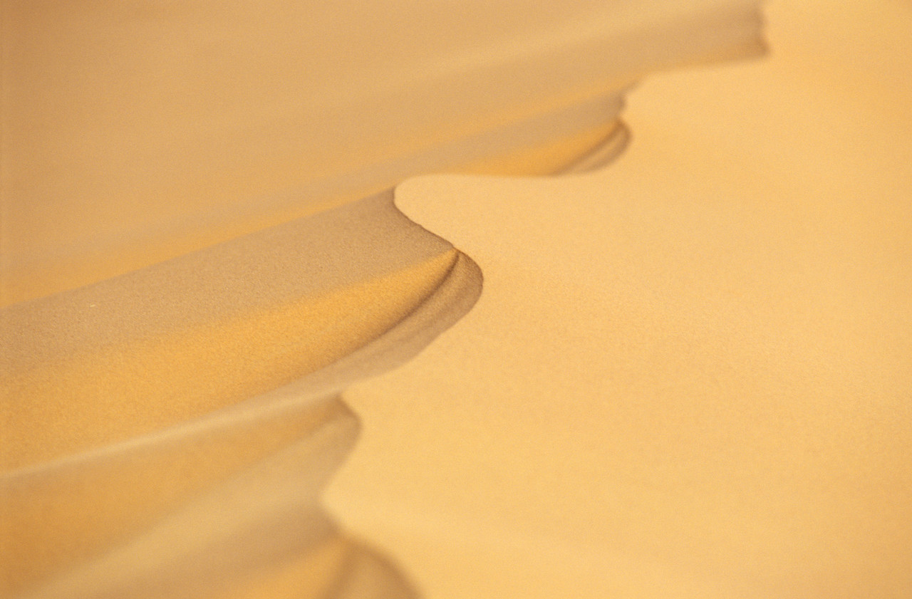
You use me to build a castle,
or let me run through your hand.
I cover lots of beaches,
I am the ______________.

I sail along in the ocean,
I’m the right shape to float.
I can carry lots of people,
I am a _________________.

I come in all different colours and sizes,
and can carry your sandcastle’s flag.
I keep your belongings tidy and safe,
I am a ____________________.

I am lots of fun to play with,
just don’t drop me or let me fall.
I can be lots of colours,
I am a ________________.

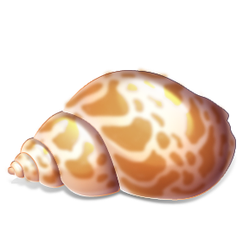
You can use me to listen to the sea,
and sometimes the wind as well.
I used to be home to a small sea creature,
I am a ___________________.

Seaside Riddles
You use me to build a castle,
or let me run through your _______.
I cover lots of beaches,
I am the ______________.

I sail along in the ocean,
I’m the right shape to __________.
I can carry lots of people,
I am a _________________.

I come in all different colours and sizes,
and can carry your sandcastle’s___________.
I keep your belongings tidy and safe,
I am a ____________________.

I am lots of fun to play with,
just don’t drop me or let me ___________.
I can be lots of colours,
I am a ________________.

You can use me to listen to the sea,
and sometimes the wind as _________.
I used to be home to a small sea creature,
I am a ___________________.
Seaside Riddles
You use me to build a castle,
or let me run through your _______.
I___________________________________,
I am the ______________.

I sail along in the ocean,
I’m the right shape to __________.
I____________________________________,
I am a _________________.

I come in all different colours and sizes,
and can carry your sandcastle’s___________.
I___________________________________,
I am a ____________________.

I am lots of fun to play with,
just don’t drop me or let me ___________.
I___________________________________,
I am a ________________.

You can use me to listen to the sea,
and sometimes the wind as _________.
I____________________________________,
I am a ___________________.
Seaside Riddles
Remember the 2nd and last lines should rhyme!

You use me to build a castle,
_________________________________.
I___________________________________,
I am the ______________.

I sail along in the ocean,
_______________________________.
I____________________________________,
I am a _________________.

I am lots of fun to play with,
___________________________________.
I___________________________________,
I am a ________________.

You can use me to listen to the sea,
_____________________________________.
I____________________________________,
I am a ___________________.

Words to help

hand ball well fall

beach bag float shell

flag sand boat

Words to help

hand fall well

flag float

Remember to think about the objects size, shape, colour, how it feels and what it’s for.

Challenge- can you choose another word from your sheet yesterday and use the rhymes you thought of to make a riddle?

