The is
all turtle green.

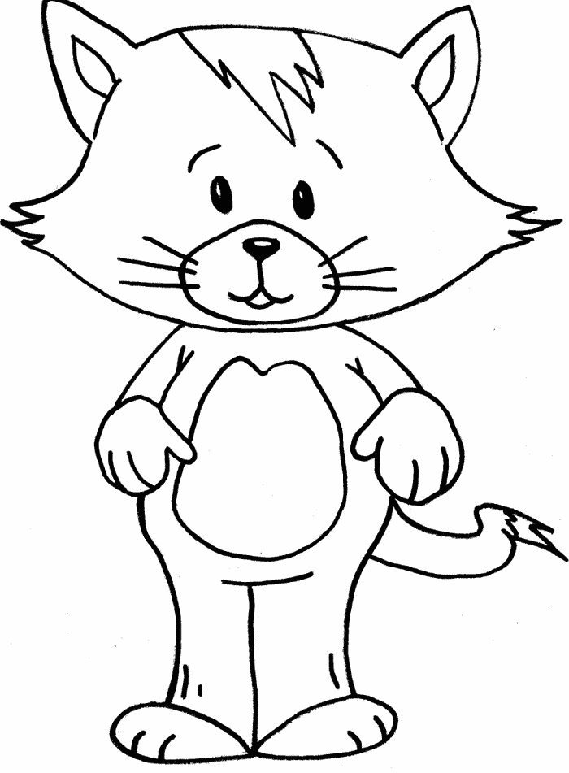
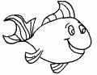
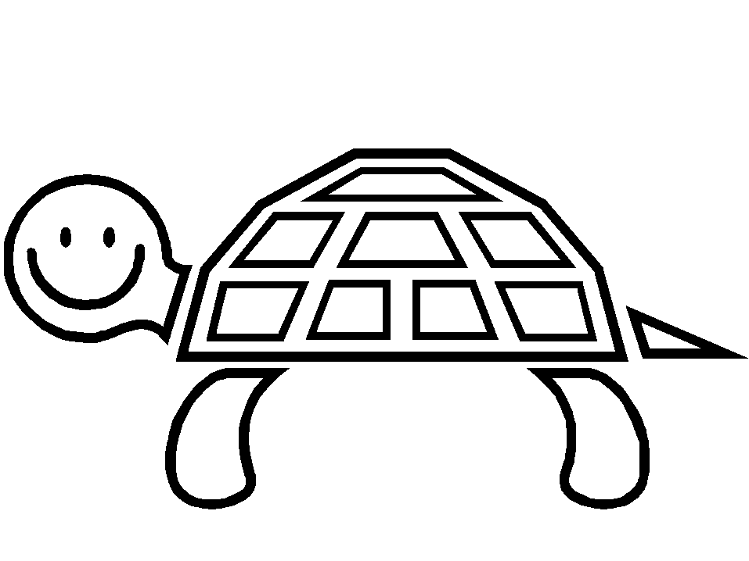
Name ____________________________
and cat
This red
blue. is
The is
red. fish green and
is nice

Name ____________________________
with of
I play
toys. lots is
to I
party. a
want have
like sing
to We
a song.

