LO: to gather evidence using secondary sources
Shakespeare Plays
What is the first thing you do when you want to find out about what happened in the past? Most people would probably say that they would look in a book, ask a teacher or other expert or check it out on the internet. These are all excellent sources of information. Resources like this can tell us not only historical facts but we can also use them to find out what other people think about what happened, in other words their interpretation of history. This type of information is called secondary evidence.
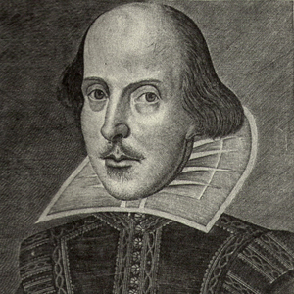
Using secondary sources, find out the names of some of Shakespeare’s most well-known plays using the abbreviations as a clue – one has been done for you!
RAJ | Romeo and Juliet
KL
M
P
TGOV
AYLI
AWT
TMWOW
TMOV
AMND
TTOTS
H
TN
TT
O

