Advert 1 |  | Advert 2
The Skate – o – Matic  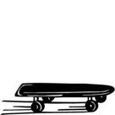  This thing has been around for years so I suppose you could buy one if you wanted to.  “It’s not bad.”  Norris Cole – Coronation Street  It has 4 wheels.  It has a board to stand on.  It goes a bit fast.  Available in black!  £50 each |  | The Skate – o – Matic  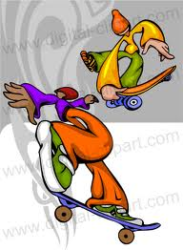  “The brand new way to travel! Everyone’s doing it!”  Comes in 15 skate - tastic colours!  Justin Bieber  Do you get fed up of walking in the rain?  Had enough of standing in the bus queue?  Well look no further, the outstanding Skate – o – Matic is finally here!  It’s skate – tastic!  Get to your friend’s house or to school in double quick time with the sensational Skate – o- Matic.  - It has 4 different speeds!  - An amazing anti-slip foot board!  - 4 remarkable rumble wheels!  - Comes with a life time guarantee!  I’ve got one – they’re great!  Bob of Balby  - Bargain price of £25.99  Only a few left! Be quick!

