Big writing about space

 | moon | 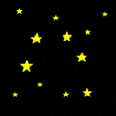 | space
 | star |  | telescope
 | alien | 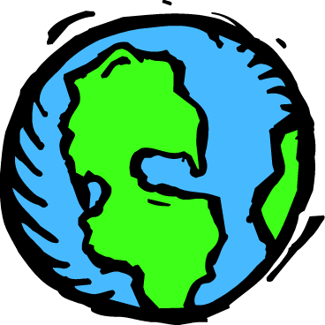 | earth
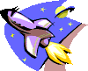 | rocket |  | house
 | astronaut |  | scared
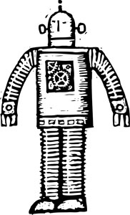 | robot | 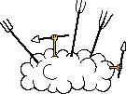 | fight
 | rocks |  | planet

