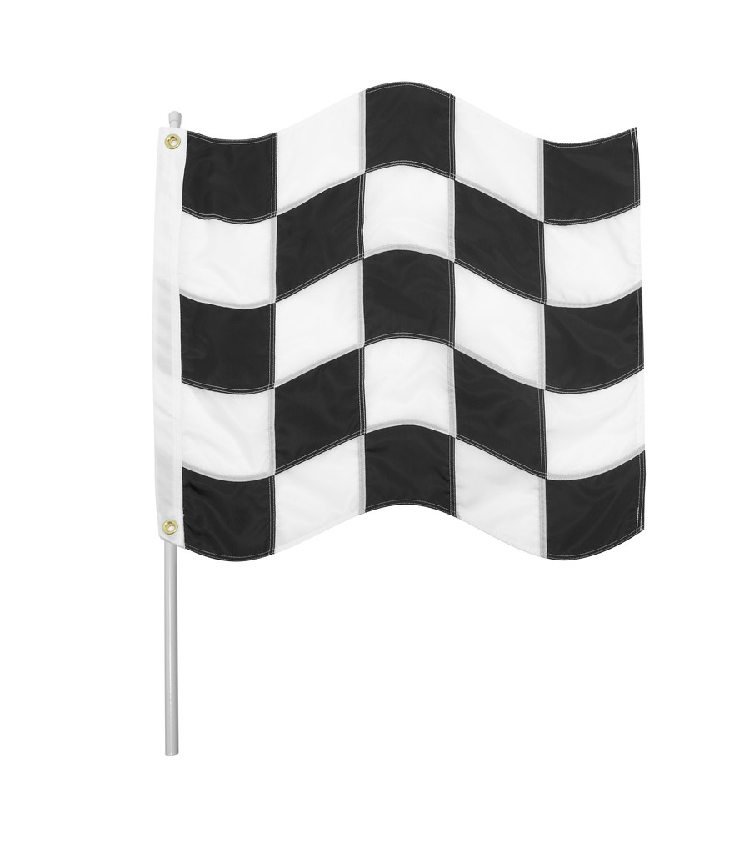
Climb to the top of the castle to escape!

Finish  48 |  | Move back 3  47 |  | Miss a go  46
Spell  41 | 42 | Spell  43 | 44 | Spell your name with your eyes closed 45
Spell  40 | Miss a go  39 | 38 | Spell  37 | 36
Spell  31 | 32 | List the vowels  33 | 34 | Move on 3  35
30 | Move back 3  29 | 28 | Say the alphabet  27 | 26
Spell  21 | 22 | Back to the start  23 | 24 | Spell  25
20 | Move on 5  19 | 18 | 17 | Spell  16
Miss a go  11 | 12 | Spell  13 | 14 | Move back  2  15
Spell  10 | 9 | 8 | Move on 2  7 | 6
Start  1 | 2 | Spell  3 | 4 | Miss a Go  5
Roll the dice. Do what the square says. If it says “spell” your game partner must ask you one of your spellings. If you get it right, you get another turn. If you get it wrong, you stay where you are until your next turn. First one to the top wins! (Extra hard rule: must roll the exact number to finish!)

