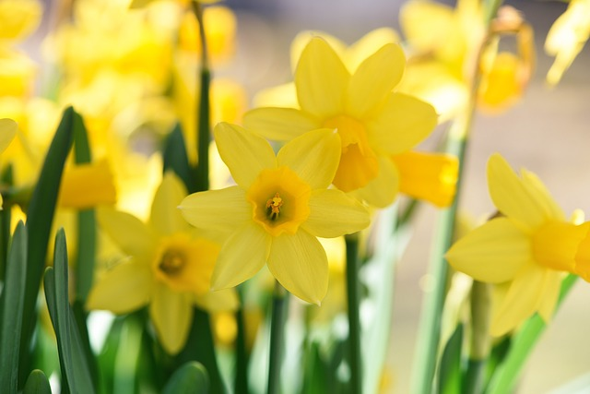
Spring Haiku
A haiku is a traditional Japanese poem. It is three lines long and only has 17 syllables. (Line 1 = 5 syllables, line 2 = 7 syllables and line 3 5 syllables). This is a common format for writing haikus: The subject enters the poem in line 1; in line two the subject does something or is described; and in line 3 the subject exits the poem. (Think in-do-out). This is a haiku I wrote using this format;
Spring brings daffodils,
Bright yellow, swaying, flowers,
Blossoms that dance by.
Now try to write your own spring haiku; you do not have to stick to the format of in – do – out but you do have to follow the 5:7:5 syllable rule.

