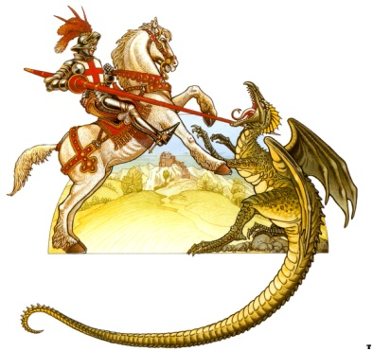
St. George and the Dragon
Read the Legend of ‘St. George and the Dragon’ carefully and then answer the following questions in full sentences.

- What are the features of a legend?

- The story of ‘St. George and the Dragon’ is a legend, how is a legend different from a Myth?

- What was the Dragon fed first to keep it happy?

- When the entire young girls in the land were fed to the dragon what was the king’s solution to feed the dragon?

- How do you think the people of the kingdom felt about this solution?

- Where were the servants taking the princess?

- Who did the princess meet on her way?

- What was St. George’s challenge?

- What did the King offer the people of the kingdom? Why?

- How did George feel when his spear did nothing to hurt the dragon?

- What was the magical element in this legend?

- How do you think St. George felt after he killed the dragon?

- What did you like and dislike about this legend?

St. George and the Dragon
Read the Legend of ‘St. George and the Dragon’ carefully and then answer the following questions in full sentences.

- What are the features of a legend?
___________________________________________________________________________
___________________________________________________________________________

- What was the Dragon fed first to keep it happy?
___________________________________________________________________________
___________________________________________________________________________

- When the entire young girls in the land were fed to the dragon what was the king’s solution to feed the dragon?
___________________________________________________________________________
___________________________________________________________________________

- How do you think the people of the kingdom felt about this solution?
___________________________________________________________________________
___________________________________________________________________________

- What was St. George’s challenge?
___________________________________________________________________________
___________________________________________________________________________

- What did the King offer the people of the kingdom? Why?
___________________________________________________________________________
___________________________________________________________________________

- What was the magical element in this legend?
___________________________________________________________________________
___________________________________________________________________________

- What did you like and dislike about this legend?
___________________________________________________________________________
___________________________________________________________________________
St. George and the Dragon
Read the Legend of ‘St. George and the Dragon’ carefully and then answer the following questions in full sentences.

- What was the Dragon fed first to keep it happy?
______________________________________________________________________________________________________________________________________________________
___________________________________________________________________________

- When the entire young girls in the land were fed to the dragon what was the king’s solution to feed the dragon?
______________________________________________________________________________________________________________________________________________________
___________________________________________________________________________

- What was St. George’s challenge?
______________________________________________________________________________________________________________________________________________________
___________________________________________________________________________

- What was the magical element in this legend?
______________________________________________________________________________________________________________________________________________________
___________________________________________________________________________

- How did St. George kill the dragon?
______________________________________________________________________________________________________________________________________________________
___________________________________________________________________________

