LI: Decide which sentences are questions and which are statements. Put them in to separate piles


I am going swimming tomorrow


Was the cake tasty


Do you take your dog for a walk


Was it raining at hometime

The cake was very tasty and I had two slices


Is the weather going to be hot today


I have joined the school football team

When are you going swimming

It was raining at hometime and we all got wet.

Are you in the school football team

I have a dog and I take it for a walk everyday

Today the weather is bright and sunny

LI: Change these statements in to questions

I am going swimming tomorrow.

I take my dog for a walk every day.
It was raining at hometime.

The cake was very tasty and I had two slices.


I would like a puppy for my birthday.


Change these questions in to statements

Have you finished your reading book?

Are you in the school football team?


Can I come to your party?


Is Ali going to come to the party?

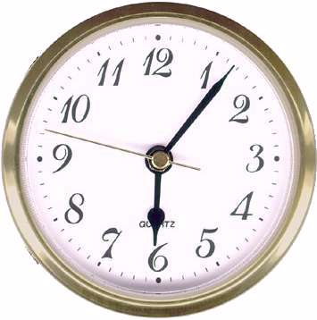

What time will the party end?

