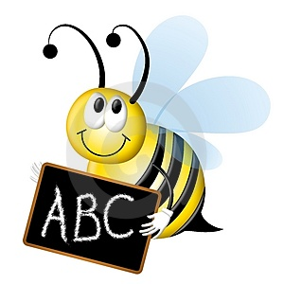
Super Spellings

Suffixes

Word | -ed | -ing
hop
run
shut
clap
swim

What happens when you add a suffix?

Word | -ing | -ful
write
hope
ride
smile
drive
decide

What happens when you add a suffix?

Use the words above in some sentences.
Be careful when adding a suffix.
Super Spellings

Words ending in -le

grumble | battle | needle
handle | middle | people
simple | muddle | startle
bundle | apple | steeple
crumple | giggle | noodle

What’s the rule for words ending in –le?

Short vowel sound = double consonant between the vowel and -le.
(candle, handle, sparkle, kettle)

Long vowel sound = single consonant between the vowel and –le.
(people, fable, needle )

Super Spellings

Words ending in -le

Two different consonant before the -le | Two consonants before the -le | One consonant before the -le
grumble | battle | needle
handle | middle | people
simple | muddle | bible
bundle | apple | steeple
crumple | giggle | noodle

What’s the rule for words ending in –le?

Short vowel sound = double consonant between the vowel and -le.
(candle, handle, sparkle, kettle)

Long vowel sound = single consonant between the vowel and –le.
(people, fable, needle )

………………………………………………………………………………………………………………

-ckle | -able | Double letter  + le | -cle | -dle | -ble | -ible | -ple
chuckle | table | bubble | uncle | candle | double | sensible | example
prickle | vegetable | apple | cycle | handle | trouble | horrible | simple
tickle | reliable | ripple | icicle | needle | humble | bible | crumple
cackle | cable | paddle | obstacle | noodle | grumble |  | dimple
trickle | fable | nettle | miracle | poodle | rumble
 |  | cuddle | circle | bundle
 |  | sizzle | bicycle
 |  | wriggle
 |  | hobble

Super Spellings

Regular Verb Endings

What is a verb?
List some on a whiteboard.

It

It hops and wobbles

Over rocks and stones.
It whimpers and whispers

And softly moans.

In darkness it glows
Like the moon in the sky.

What is it, this form, this creature
this mess?
I try and I try to look at its face.

I laugh and I cry, I’ve got it!
Can you guess?
It’s a poor alien from outer space!

Double consonant | Verb+ed | Verb ending in -y
skip - skipped | searches - searched | carry - carried

What are the rules for verbs?

Single syllable verb, ending in a single consonant letter preceded by a single vowel letter = double the final consonant
(skip = skipped, drop = dropped)

Verbs with more than one syllable or a long vowel sound = remove the s/es and add ed.
(looks = looked, searches = searched)

Verbs ending in –y, preceded by a consonant = change the –y to an i and add ed.
(carry = carried, cry = cried)

