Name______________ Date___________
‘Th’ or ‘f’?
Look at each picture and decide which sound is missing from it. Write the correct sound on the line.
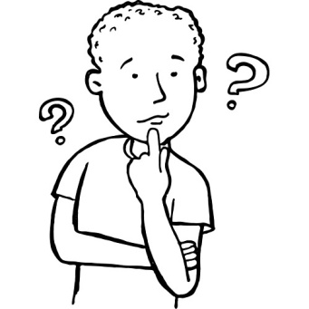
___ish ___ink ___ree

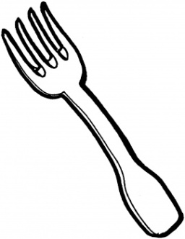
___ire ___umb ___ork


___orty ___irt ___ree The pig is not fat it is ___in.

