throw, thimble, thirty, thirsty, thistle, thumb,
throne thinker

Match words and pictures


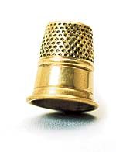
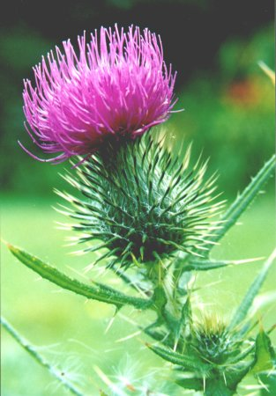
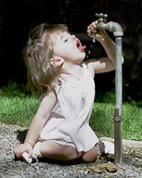
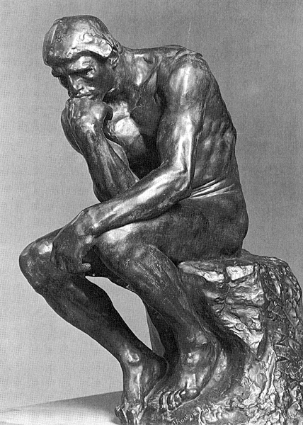
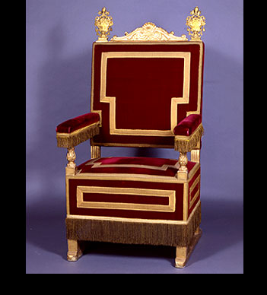
30

T E X P S T R T J Q
O H N P W P H H B G
A F I O U I Q I J R
X V R N R O D S S E
O H M S K H Z T S Y
T E T B H E T L X T
F Y H X L T R E T R
P H E L B M I H T I
T H U M B R N V J H
Q N H U B K P E J T

Find the words in the wordsearch.
Choose 3 of the words. Write 3 sentences using the words

