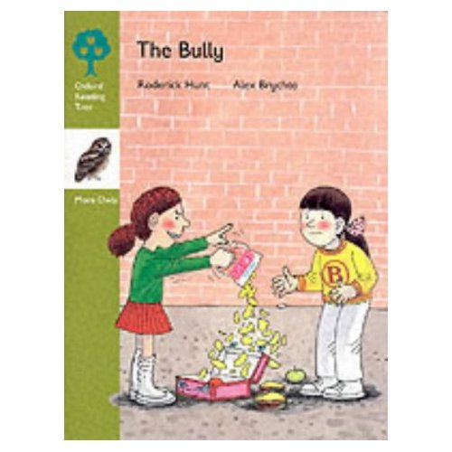
The Bully

- Look at the front cover. What is the girl doing to Biff?
______________________________________________________________________________________________________________
- Look at page 1. How can you tell that the girl isn’t very friendly?
______________________________________________________________________________________________________________
- What is the new girl called?
_______________________________________________________

Read the following sentences and write down Yes/No

- Chip scribbled on Rosie’s picture. _________
- Rosie took Biff’s crisps and called her toffee apple.______
- Wilma was smaller than Rosie. _____
- The magic key glowed when Chip held it. ______

Word search: Can you find 5 words with 5 letters each?

_____________________________________________________________________________________________________________________________________________________________________________________________________________________________________________________________________________________________

Unjumble the sentences.

Chip. cross with Rosie was
__________________________________________________________________________________________________________________

The began children laugh. To
__________________________________________________________________________________________________________________

magic The key a face. parrot Rosie gave
___________________________________________________________________________________________________________________________________________________________________________

grown-up tell Always about a bullies.
__________________________________________________________________________________________________________________

Word endings
Write down 5 words in the text that end with ‘y’?
_____________________________________________________________________________________________________________________________________________________________________________________________________________________________________________________________________________________________

How did Rosie upset Biff?  What secret did Rosie force Chip to tell?  Where did the magic key take them?  What magic did the magic key do?  What did Chip and Wilma see at school the next day?  What did Mrs May say about bullies? | The magic key took the children to the playground.  The magic key made all of things that Rosie said true, gave her a motor mouth, parrot face and dinosaur brain.  The next day at school Chip and Wilma saw some older children bullying Rosie.  Mrs May said Nobody likes bullies, bullies are nasty, always tell a grown about bullies as she doesn’t want bullies in the school.  Rosie took Biff’s crisps and called her a toffee nose  The secret Chip was forced to tell Rosie was about the Magic adventures with the key.
Match the question to the answer

Draw the three things that the Magic Key turned Rosie into.

Look at page 32. What do you think will happen next?
_____________________________________________________________________________________________________________________________________________________________________________________________________________________________________________________________________________________________

What lesson have you learned from reading this book?
_____________________________________________________________________________________________________________________________________________________________________________________________________________________________________________________________________________________________

How would you evaluate your reading?

