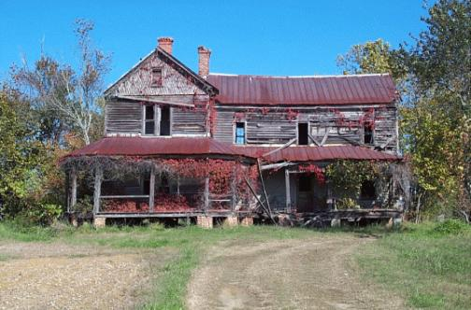
The Deserted House

To whom it may concern,
My name is
And I have lived in this house for years with
We have loved this house dearly and have, until now many fond
Memories. I remember last autumn when
But a few months later it happened. Now I find myself sitting here at dusk writing this letter to explain to you why I must leave this house and why so many strange things happen here. As you must have already noticed the animals come nowhere near this house.

And that is the story of how this once beautiful house is how you find it now. I hope that

Yours faithfully

