The Shiny Key
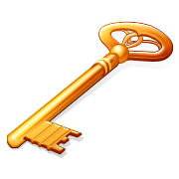
- Which bird was Chip watching a television programme about? _________________________________

- Make a list of 7 things found in the chair. _________________________________

- Why did the children need to clean the key? _________________________________

- Who did the ring Biff found belong to? _________________________________

- What was the real thief in the story? _________________________________

- Make a list of 7 things found in the magpie’s nest. _________________________________

- Write the names of 6 shiny things in your house.

1. | 2. | 3.
4. | 5. | 6.

