Work Booklet –

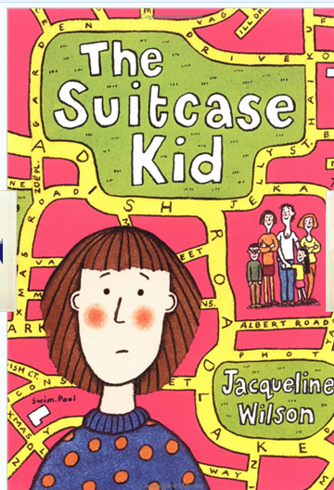
- Look carefully at the book cover, what do you think this book is going to be about? What kind of story do you expect it to be (i.e. crime, fantasy, sci-fi)? Why do you think this?

- The author keeps referring to someone called Radish. Who do you think Radish is, and what role do you think Radish has in Andy’s life?

- What point of view is the story being told from (i.e. the narrator, the main character)? How do you know?

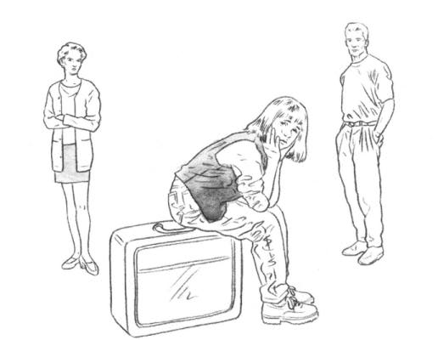

- Draw a picture of what you think Katie (Andy’s stepsister) looks like; use the book to help you. When you have done this, label her personality traits around the outside.

- Have your thoughts changed on what the book could be about? If they have, please write down your revised thoughts on what the book is about.

- On page 22, Andy says that she ‘concocted an evil spell.’ Write down what you think she might have said in her spell.

- In chapter ‘C’, Andy describes Mulberry Cottage in detail. Draw what you think Mulberry Cottage looks like.

- Before going on the Chapter ‘F’, write Andy’s name in the middle of your page. Now, around the outside of Andy’s name, write down the other characters names. If you think Andy likes them a lot, write their name close to Andy’s, if you think Andy doesn’t like them, write their name far away from Andy’s. (For example, she loves her Mum, so write Mum very close to Andy’s name).

- In Chapter ‘I’, Andy talks about being ill. Do you think she is really ill? Or, do you think she is pretending? Give reasons for your answers.

- After reading Chapter ‘J’, have a think. Do you think Andy’s Mum is being fair? Is it right to call other people names? If you were Andy, how would you feel? Give reasons for your answers.

- Chapter ‘L’ talks about the house in Larkspur Lane. Who do you think owns this house? Why do you think they have never come to tell Andy off?

- During Chapter ‘M’, Andy goes to the family counsellor again. Why do you think the counsellor always asks about Radish?

- Why do you think Graham made a boat for Andy?

- After reading Chapter ‘N’, do you think that Andy should be more tolerant of Katie? Can we, as readers, become more tolerant of Katie?

- Do you think it is mean that Paula, Graham and Katie’s grandparents don’t include Andy in the present giving? Why?

- If you had a camera and could take pictures of 4 people, who would you photograph and why?

- Having read Chapter ‘R’, what do you think is going to happen to Radish? Why do you think Andy is so upset?

- Do you think Andy did the right thing by sneaking out of the house?

- After reading Chapter ‘Y’, look back at your answer to question 8, can you change it now? Add on the other characters and amend you previous answers, if you think you should.

- Write a review of the book, would you recommend it to a friend? Why/why not?

