The Waiting Game

Her eyes were emeralds in a porcelain mask
The serpents her hissing long locks
Her gaze was hard, a knife cutting air
Yet once she was known as fair

Her watery grave was a silent blue tomb
A nautical queen from the depths
Her fingers were tentacles, beckoning in
Her heart was made only of tin

Still there she lies
A beacon of gloom
A dream broken hard on the rocks
Her song is a scream
Her wishes white dust
As she waits for the sun from above
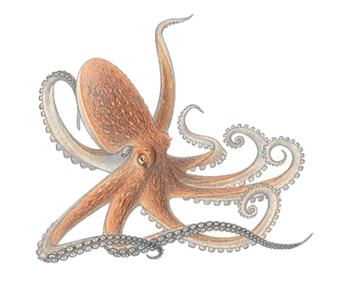
LO: I can write a personification poem using only metaphors

